ABOUT THE ERRORS OF MEASUREMENTS

To measure some physical quantity - it means to compare it with the other one from same type taken as the unit of measurement.
From whatever precision measurement has not been made, the values ​​obtained for the most part different from each other in repeated measurements, or rather the coincidence of these values ​​is not obvious. Perform accurate measurement - this means being able to choose among distinct numbers closest to the true value of the measured value.
The value of error admitted during the experiment depends on the method used, the accuracy of measure instruments and the skill of the work of the observer. Errors made during the experiment, by their character are divided into systematic and random.
Assume that zero point of the thermometer mistakenly moved to + 0.50 C. When working with a thermometer the error will be systematic. Taking into account the errors made in the calibration of the thermometer, you can get rid of the error. To do this, before the experiment is important to check the thermometer.
If the bias is eliminated, there is only random error. The complete elimination of the random error is not possible, but it is possible to calculate the degree to which this error affects the measurement result.
Random error can be calculated as follows. Suppose that in direct measurements of a physical quantity in the same conditions, the values ​​a1, a2, a3, ... an are received. If one of the numbers obtained during the repeated measurement is greater than the true value of the physical quantity, someone other may be less. It is difficult to say which of the received physical quantity values ​​closer to the true value of this quantity.
According to the theory of probability among the values ​​obtained by multiple measurements, the number of values larger than the true value, and the number of values ​​less than the true value have the equal probability.
Therefore, the value closest to the true value of a physical quantity is the arithmetic average of the numbers obtained in the measurements:
$$a=\frac{a_{1}+a_{2}+a_{3}+\text{.}\text{.}\text{.},+a_{n}}{n}$$
where n - the number of measurements.
By comparing the values ​​obtained in repeated measurements of a physical quantity, with a mean value, we get:
$$\begin{aligned}a−a_{1}={Δa}_{1}; \\ a−a_{2}={Δa}_{2}; \\ a−a_{3}={Δa}_{3}; \\ \text{.}\text{.}\text{.}\text{.}\text{.}\text{.}\text{.}\text{.}\text{.}\text{.}\text{.}\text{.}\text{.}\text{.}\text{.}\text{.}\text{.}\text{.} \\ a−a_{n}={Δa}_{n}\end{aligned}$$
where ${Δa}_{1},{Δa}_{2},{Δa}_{3}\text{.}\text{.}\text{.}\text{.},{Δa}_{n}$- the errors made at each measurement separately.
These errors are called absolute error of each measurement.
Expression.
$$\frac{\left|{Δa}_{1}\right|+\left|{Δa}_{2}\right|+\left|{Δa}_{3}\right|+\text{.}\text{.}\text{.}+\left|{Δa}_{n}\right|}{n}=Δa$$
It is called the average absolute error of measurement.
The probability theory shows that in cases where the number of direct measurement is very large, the algebraic sum of positive and negative errors of the individual measurements is zero,
those $\sum_{i=1}^{n}{±{Δa}_{i}=0}$.
Also, when the number of measurements are very large, errors with a large absolute value are rare .
We cannot estimate the degree of measurement accuracy using only the value of the absolute error of a physical quantity.
To assess the accuracy of the experiment uses the concept of relative error. The relative error of a1, a2, a3, ... an, obtained from individual measurements of the physical quantity, are:
$\frac{{Δa}_{1}}{a_{1}},\frac{{Δa}_{2}}{a_{2}},\frac{{Δa}_{3}}{a_{3}},\text{.}\text{.}\text{.},\frac{{Δa}_{n}}{a_{n}}$.
and the average relative error
$Ε=\frac{Δa}{a}$ (1)
For the determination of many physical quantities it is necessary to resort to the help of the formulas. In this case, the error of experimental result is calculated, given the errors in the measurement of separate values in the formula.
To calculate the error of measurement of any physical value determined by an indirect route, you must:
1) take the logarithm of this formula;
2) differentiate the resulting expression;
3) replace the sign of the differential by the sign of the increment;
4) due to the fact that the greatest error is calculated, take all the errors with the sign (+).
Let us explain this with an example.
Assume that the Young's modulus is determined by the stretching.
It is known that the following formula is used
$Ε=\frac{8\text{FRl}}{{πD}^{2}\text{ah}}$
Take the logarithm of this formula to calculate the relative error,
$$\text{ln}E=\text{ln}8+\text{ln}F+\text{ln}R+\text{ln}l−\text{ln}π−2\text{ln}D−\text{ln}a−\text{ln}h,$$

Then differentiate the resulting expression
$$\frac{\text{dE}}{E}=\frac{\text{dF}}{F}+\frac{\text{dR}}{R}+\frac{\text{dl}}{l}−2\frac{\text{dD}}{D}−\frac{\text{da}}{a}−\frac{\text{dh}}{h}$$

(Value $\frac{dπ}{π}$be ignored).
Replacing the sign (-) in front of with a sign (+) obtain the relative error in the determination of the Young's modulus expression
$$\frac{ΔE}{E}=\frac{ΔF}{F}+\frac{ΔR}{R}+\frac{Δl}{l}+2\frac{ΔD}{D}+\frac{Δa}{a}+\frac{Δh}{h}$$

If in the experience you get the value :
$F=1,5H$ $R=\text{160}\text{cm}$
$D=0,8\text{mm}$ $h=\text{30}\text{mm}$
$Δa=0,1\text{mm}$ $ΔD=0,\text{01}\text{mm}$
$a=2,5\text{cm}$ $l=\text{150}\text{cm}$
$ΔR=1\text{mm}$ $ΔF=0,\text{01}H$
$Δh=0,5\text{mm}$ $Δl=0,1\text{cm}$
the error will be expressed as follows:
$\frac{ΔF}{F}=\frac{0,\text{01}⋅\text{100}}{1,5}=0,\text{67}$%; $\frac{ΔR}{R}=\frac{1⋅\text{100}}{\text{1600}}=0,\text{06}$%;
$\frac{Δl}{l}=\frac{0,1⋅\text{100}}{\text{150}}=0,\text{07}$%; $2\frac{ΔD}{D}=\frac{2⋅0,\text{01}⋅\text{100}}{0,8}=2,5$%;
$\frac{Δa}{a}=\frac{0,1⋅\text{100}}{\text{25}}=0,4$%; $\frac{Δh}{h}=\frac{0,5⋅\text{100}}{\text{30}}=1,7$%;

As can be seen from these expressions, the relative error made in measuring of the wire diameter, 35 times larger relative error made in measuring of its length. Clearly in this case there is no point to measure the length of wire with such precision. , You should try to determine more precisely the diameter of the wire to reduce experimental error. And for this reason, before you begin the experience, it is necessary to take into account what the error can be done, and depending on it to set the precision with which will need to measure the individual values.

LABORATORY № 1
DETERMINATION OF THE MOMENT OF INERTIA OF THE SOLIDS USING A TORSION PENDULUM
Objective: To study the method for determining the moment of inertia of the solid bodies of various shapes using a torsional pendulum.
Accessories: torsional pendulum, loads of varying weight and shape, a stopwatch, an etalon cylinder, caliper.
Works theory
When studying the motion of a material point, we use the value of the momentum, force, kinetic energy. In translational motion, all points of the body move with equal speed and with the same trajectory. And for this reason, the expression of momentum and kinetic energy of the moving body are identical to expressions of material points.
With the rotational motion of the various bodies, rotors, generators, wind turbines and propellers etc. we often meet in practice. The feature of rotational motion is that the body components, describe concentric circles at various speeds. If the body performs rotational motion, there is a need for the expression of various dynamic quantities through angular velocity which is the same for all points of the body. In this regard such quantities as the torque value, the angular momentum and inertia are considered.
As a characteristic of the distribution of mass, moment of inertia also characterizes the inertia of a rotating body.
$J=\sum_{i=1}^{n}{m_{i}r_{i}^{2}}$ или $J=\int_{V}{{ρr}^{2}\text{dV}}$
where m_{i} - mass of the particles constituting the body,
r_{i} - the distance from these particles to the axis of rotation,
$ρ$- Density,
V - volume of the body.
Torsion pendulum - a body hanged on a thin thread in the gravity field. When rotating such body around a fixed thread by a small angle in thread the torque proportional to the angle of rotation is appeared. As a result, the body begins to perform harmonic oscillations around the thread (Figure 1).
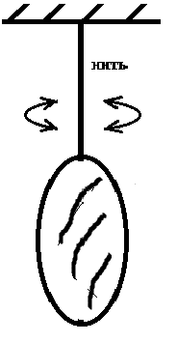
Apply to the body which commits the torsional oscillations, the basic equation of dynamics of rotational motion.
thread

$M=J\frac{d^{2}ϕ}{{\text{dt}}^{2}}$ (1)
.
Where M - is a torque relative to the rotational axis,
Fig. 1
J - moment of inertia with respect to the same axis,
$\frac{d^{2}ϕ}{{\text{dt}}^{2}}$- angular acceleration.
For small values of the angle the rotation torque of the elasticity is proportional to this angle
$M=Gϕ$. Where G - is called the module of torsion and has constant numerical value for this thread. Taking this into account, the equation (1) can be written as
$J⋅\frac{d^{2}ϕ}{{\text{dt}}^{2}}=−Gϕ$ or $\frac{d^{2}ϕ}{{\text{dt}}^{2}}+\frac{G}{J}ϕ=0$ (2)
which is the differential equation of harmonic oscillations. Taking into account that $\frac{G}{J}=ω^{2}$ for torsional oscillation period the following expression is obtained

$T=\frac{2π}{ω}=2π\sqrt{\frac{J}{G}}$ (3)

Device description
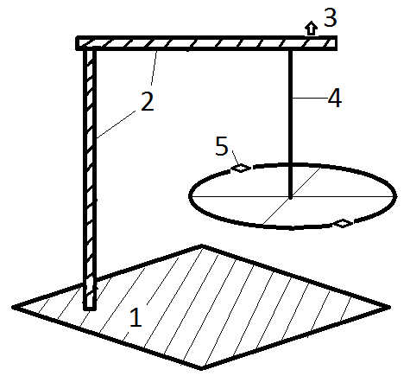
The scheme of the device is shown in Figure 2. The device consists of a base 1, counters with an arm 2, collet chuck 3, a metallic suspension (thread) 4, disc 5 with two clamps, the etalon and the test loads. With this setting you can determine the moment of inertia of any object with mass not greater 5kg located in the center.
First defined by the moment of inertia of the device itself. For this the disc is centered by means of clamps (Figure 2) about a vertical axis. Then by turning the disc around this axis at a small angle$ϕ$, achieve the torsional oscillations. Using the stopwatch determine the time t₀, necessary to perform $п_{0}=\text{20}−\text{30}$ number of oscillations, while
Fig. 2
calculating the period of oscillation by the formula $T_{0}={t_{0}}/{n_{0}}$. On the other hand the connection between the period $T_{0}$of the device, its moment of inertia $J_{0}$and modulus of torsion $G$ is given by
$T_{0}=2π\sqrt{\frac{J_{0}}{G}}$ (4)

This formula includes unknown quantities $J_{0}$and$G$. To determine them an etalon cylinder with a known moment of inertia is setting to disc $J=\frac{1}{2}{\text{mr}}^{2}$

where m - is the mass of the cylinder, r - the radius. If the axis of rotation of the cylinder is parallel to the axis of rotation of the device and the distance between them is d, then according to Steiner's theorem the moment of inertia of the cylinder
$J_{1}=\frac{1}{2}{\text{mr}}^{2}+{\text{md}}^{2}$ (5)
The period of the device with the etalon cylinder is calculated as
$T_{1}=2π\sqrt{\frac{J_{0}+J_{1}}{G}}$ (6)
From the expressions (4) and (6) we obtain
$J_{0}=\frac{T_{0}^{2}J_{1}}{T_{1}^{2}−T_{0}^{2}}$ (7)
$G=\frac{4π^{2}⋅J_{1}}{T_{1}^{2}−T_{0}^{2}}$ (8)

When the etalon cylinder is replaced by another load, the period of the device with this load will be

$T=2π\sqrt{\frac{J_{0}+J}{G}}$ (9)

Where $J$ the moment of inertia of the load. Substituting the values $J_{0}$and $G$from (7) and (8) into (9) we obtain the expression for

$J=\frac{T^{2}−T_{0}^{2}}{T_{1}^{2}−T_{0}^{2}}m(\frac{1}{2}r^{2}+d^{2})$ (10)

Procedure and analysis
1. Align the installation. Turn the disc at a small angle $ϕ$to oscillate the system about a vertical axis. Measure by a stopwatch the time $t_{0}$in which $n_{0}$ (about 20 - 30) oscillations are completed. Calculate the period of oscillation of the device. The measurements repeated at least three times.
2. Measure the weight of the etalon and its radius. Set the etalon on a disk of the devise, so that the etalon's symmetry axis was parallel to the axis of rotation of the device. Measure the distance $d$ between the axles.
3. Determine, as described in paragraph 1, the period $T_{1}$of the system with the etalon load.
4. After removing the etalon from the disc , install the study load on it and determine the period of oscillation using the above method $T=\frac{t}{n}$.
5. Substituting the values $T_{0},T_{1},T,m,r,$and $d$ in the formula (10) calculate $J$.
6. The measurements were repeated 3-5 times obtained numerical values recorded in the table and calculate the relative measurements error.

Measurement Table

№ | $$T_{0,}s$$ | $$T_{1},s$$ | $$T,s$$ | $$m,\text{kg}$$ | $$r,m$$ | $$d,m$$ | $$J,\text{kg}⋅m^{2}$$
1
2
3

Questions to the lab. Kinematics of rotational motion. The basic equation of dynamics of rotational motion, Steiner theorem, the moment of inertia of some bodies of regular geometric shape.
Laboratory Work # 2
Determination of moment of inertia by the method of falling

Work Objective: To study a dynamic method of determination of the moment of inertia.
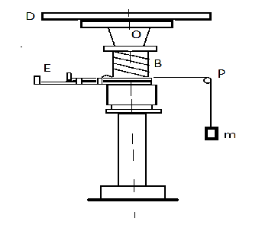
Accessories: Installation for determining of the moment of inertia, metallic hoop, stopwatch, vernier caliper, ruler, loads of different masses..
Short theoretical information
The method of dropping is one of the methods of determining the moment of inertia of solids. Its essence consists of the followings.
The device that define the moment of inertia consists of D-disk which can rotate around the OO₁ axis. For rotation of D-disc the thin rope is wrapped around B-drum on OO1 axis. This rope threw down from P pulley and m load attached to another end of rope. Falling because of gravity load pull the rope and rotate B-drum and D-disc around the axis. For keeping m load in motionless case there is E mechanism. While the load is falling, the potential energy of the load is spending to work done agents the friction force and to increasing of the kinetic energy of all system . That is why
E_{p} = E_{k1} + E_{k2} +W (1)
In here E_{p} – potential energy of load at the beginning of motion, E_{k1} – is kinetic energy of load m at the end of motion, E_{k2} –is total kinetic energy of rotation of axis, drum and disc with body at the same time, W - work done agents the friction force. If the moment of inertia of the disc I₀, the moment of inertia of the body under research is I, then
mgh =mv²/2 + (I + I₀ ) ∙ ω²/2 +W (2)
Here h- height of falling of load, m- mass of load, v- speed of load at the end of way, ω- is angular speed of rotating motion of system at the same time. If we assume the uniform accelerated falling
v=a∙t, h=a∙t²/2, hence v=2h/t, ω=2h/(r∙t) (3)

Here r-radius of drum. Considering (3) and (2)
mgh =2mh²/t² + 2(I+I₀)∙h²/(r²∙t²) + W (4)

Writing this equation for two different loads and subtracting the second equation from the first, we get:

g (m₁-m₂) = 2h (m₁/t₁²-m₂/t₂²) + (I₀+I)∙ 2h (1/ (r²∙t₁²)- 1/ (r²∙t₂²)) (5)
We may rewrite it
I₀+I= r² [g (m₁-m₂) – 2h (m₁/t₁²-m₂/t₂²)]/ 2h (1/t₁²- 1/t₂²) (6)

Here t₁ and t₂ are dropping time of m₁ and m₂ loads from h height respectively. For defining moment of inertia of body for the first time this body is removed from D-disc, then for a second time the body is placed on the disk.

The work progress
- Define the radius of drum (r) with vernier caliper.
- Set the body for defining of moment of inertia on a disc and fixing with clamp.
- Wrap the rope around B drum, one of the loads suspend to the other end of rope, lift it up and fix at this position.
- Release the disc from the clamp and allow the load falls. Measure the time of dropping. Repeated the experiment with second load.
- Calculate I₀ + I by formula (6).
- Remove the test body from the disk D, keep the clamps in the same position and repeat the measurement, as mentioned above in items 3 and 4. Calculate I₀ by formula (6), considering that I=0.
- Calculate value of I as difference between measurements with body and without body.
- Calculate the percentage uncertainty of experiment.

Data tables

For case with body on disc D
# | m₁, kq | m_{2,} kq | h, m | t₁, san | t₂, san | I+I₀, kq∙m²
1.
2.
3.

For case with empty disc D
# | m₁, kq | m₂, kq | h, m | t₁, san | t₂, san | r, m | I₀, kq∙m²
1.
2.
3.

Questions for laboratory work. Kinematics and Dynamics of rotating motion. The Kinetic energy of rotating body. Moment of inertia of some bodies which have regular geometric shape.

LABORATORY № 3
DETERMINATION OF THE FREE FALL ACCELERATION BY TURNED PENDULUM
Objective: To determine the free fall acceleration using the turned pendulum.
Accessories: Turned pendulum, stopwatch, ruler.
Works theory
Physical pendulum is called a rigid body capable to oscillate around a fixed point that does not coincide with its center of mass (Fig. 1). When turning the pendulum from the equilibrium position at an angle $ϕ$, a torque tending to return the pendulum to its equilibrium position $М=Jβ$ is appeared, where $J$- the moment of inertia of the pendulum about the axis passing through the suspension point and $β$ the angular acceleration of the pendulum obtained by force $Р_{1}$ - the component of the gravitational force. This moment is:
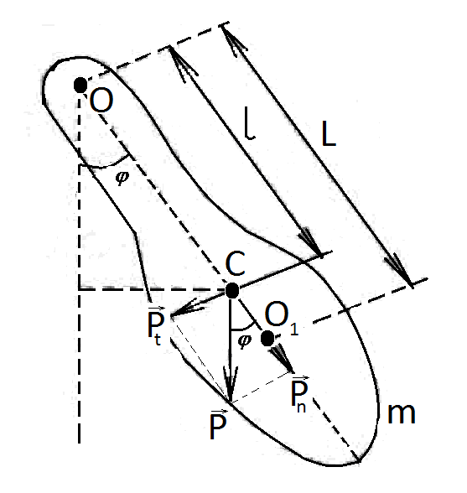
$M=−P_{1}l=−\text{Pl}\text{sin}ϕ=−\text{mgl}\text{sin}ϕ$

in the case of small oscillations $\text{sin}ϕ=ϕ$and$M=−\text{mgl}ϕ$. The sign "-" indicates that the force has such a direction that tends to return the pendulum to its equilibrium position, and is similar in this respect to the quasi-elastic force. Given that$β=ϕ$, we get the equation
Fig. 1

$ϕ^{''}+\frac{\text{mgl}}{J}ϕ=0$ (1)
When comparing of this expression with the differential equation of harmonic oscillations get
$ω^{2}=\frac{\text{mgl}}{J}$
Thus, the period of physical pendulum executing small oscillations is determined by the formula:
$T=2π\sqrt{\frac{J}{\text{mgl}}}$ (2)

where $m$- the mass of the pendulum, $l$- the distance from the center of gravity to the axis (point O) of rotation of the pendulum. If we compare the expression (2) with the expression $Т=2π\sqrt{\frac{l}{g}}$ - a mathematical pendulum period, we see that the mathematical pendulum with the length $l_{\text{np}}=\frac{J}{\text{ml}}$will have the same oscillation period, as the physical pendulum. Quantity $l_{\text{пр}}$ called the reduced length of the physical pendulum. Calculations show that the reduced length of any physical pendulum is always greater than the distance from its center of gravity to the axis of rotation. If O is the point of suspension (1), C - center of gravity, the distance ${\text{OO}}_{1}$equal to the reduced length ${\text{OO}}_{1}>\text{OC}$. O₁ point on the straight line connecting the point of suspension to the center of mass (in this case the center of inertia and the center of gravity of the pendulum are the same), which lies at a distance of reduced length from the rotation axis, called the swing center of a physical pendulum. When hanging pendulum in swing center the reduced length, and thus the oscillation period will be the same as at the beginning. Therefore, the point of suspension and the swing center exhibit the property of reciprocity: when transferring the point of suspension to the swing center the previous suspension point becomes the new center of the swing.
Determination of acceleration of gravity with the help of the so-called turned pendulum is based on the property of reciprocity. Revolving pendulum consists of a metal rod longer than one meter with applied millimeter divisions on the surface, which has two parallel fixed near its ends bearing prisms 1 and 2, on which it may alternatively be suspended.
Heavy loads A and B can be moved and fixed along the pendulum. By shifting loads we get that when hanging pendulum on any of the prisms the oscillation periods T₁ and T₂ are equal. Then the distance between the support ribs of prisms will be equal $l_{\text{np}}=L$. In this case
$$T=2π\sqrt{\frac{L}{g}}$$
and hence
$g=\frac{4π^{2}L}{T^{2}}$ (3)
Because it is difficult to achieve completely equality of periods T₁ and T₂ oscillations then in practice try to achieve that the difference between them is as small as possible. In the calculations, instead of T put arithmetic mean of T₁ and T₂,
$g=\frac{4π^{2}L}{{\left(\frac{T_{1}+T_{2}}{2}\right)}^{2}}=\frac{\text{16}π^{2}L}{{\left(T_{1}+T_{2}\right)}^{2}}$ (4)

Procedure and analysis
1. Put the pendulum on the prism 1, to measure its period T₁ based on 40 - 50 vibrations.
2. Rotate and hang the pendulum on the prism 2 and again, as mentioned above, calculate its period T₂. Loads should not be moved because they were placed so that the periods T₁ and T₂ would differ a little from each other.
3. Measure the reduced length between the prisms 1 and 2.
4. Calculate the acceleration of free fall by the formula (4).
5. Calculate the relative error of the measurements.

Measurement table.

№ | $L,$m | $T_{1},s$ | $T_{2},s$ | g, m/s²
1.
2.
3.

Questions to the lab. Harmonic oscillations. The energy of the harmonic oscillation. Mathematical and physical pendulums.

LABORATORY № 4
DETERMINATION OF THE DAMPING COEFFICIENT, LOGARITHMIC DECREMENT AND THE QUALITY FACTOR OF THE OSCILLATING SYSTEM
Objective: To determine the basic physical quantities characterizing the damped oscillations.
Accessories: Physical pendulum, stopwatch, scale for determining the oscillation amplitude.
Works theory
In any real oscillating system, a resistance force is always available, and mechanical energy, which we given during the initial excitation of vibrations, gradually transformed into heat energy. The result of this is that the vibrations are damped. Under the amplitude of damped oscillations, we understand the greatest deviation from the equilibrium position in one period.
The friction forces is in difficult way depend on the speed, but small oscillations when the velocity is small in absolute value, the friction force is proportional to velocity.
$f_{X}=−b\frac{\text{dx}}{\text{dt}}$
where b - coefficient of friction. In this case, the dependence of displacement of the oscillating body of the time expressed by the formula
. $x=A_{0}e^{−βt}\text{sin}(ωt+ϕ_{0})$
and for the angular frequency obtained by expression
$ω=\sqrt{ω_{0}^{2}−β^{2}}$
where $β=\frac{b}{2m}$- damping coefficient, $ω_{0}$- specific angular frequency of the oscillating system. The amplitude of damped oscillations decreases exponentially
$A=A_{0}e^{−βt}$
The ratio of amplitudes corresponding to moments of time, differing by a period called the damping coefficient, and its logarithm - logarithmic decrement.
$$λ=\text{ln}\frac{A_{0}e^{−βt}}{A_{0}e^{−β\left(t+T\right)}}=\text{ln}e^{βT}=βT$$
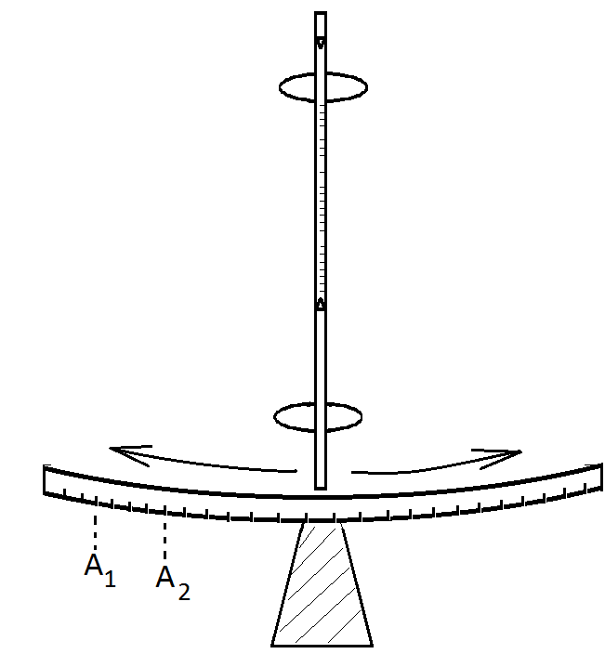
Logarithmic decrement is inverse by value to the number of
vibrations made during the time for which the amplitude decreases by $e=2\text{.}\text{71}$ times. The amplitude ratio corresponding to moments of time that differ $t=\text{TN}$ (during this time N fluctuations are committed ) is equal to $К=\frac{А_{0}е^{−βt}}{A_{0}e^{−β(t+\text{TN})}}=e^{β\text{NT}}$ (1)
and its logarithm: $\text{ln}K=β\text{NT}=λN$
then $λ=\frac{\text{ln}K}{N}=\frac{2,\text{31}\text{lg}K}{N}$ (2)
By calculating the expression $T=\frac{t}{N}$ ,
Fig. 1
we can determine the value of the damping coefficient from the formula
$β=\frac{λ}{Т}$ (3)
To characterize the oscillating system one value is often used
$D=\frac{π}{λ}$ (4)
called Q-factor of the oscillating system. The quality factor is proportional to the number of oscillations made by the system during the time for which the amplitude of the oscillations decreases by a factor e.

Procedure and analysis
1. Dismiss the pendulum (Figure 1) from the equilibrium position at 7-8 cm., let it to oscillate.
2. Fix the value of (А₁), one of the maximum deviation of the pendulum from the equilibrium position. From this moment, count the number of oscillations N, t time, spent on it, and fix the maximum deviation of the pendulum (А₂) at the last swing.
3. Calculate the ratio $К=\frac{А_{1}}{А_{2}}$, and then take the logarithm $\text{ln}K$and calculate.
4. From the known values ​​of the variables t, N, T and lnK calculate the logarithmic decrement$λ$, damping factor $β$ and the quality factor D.
5. Repeat the measurement 4-5 times to determine the average value, and. Calculate the relative measurement error.
Measurement table.

№ | $A_{1}$, cm | $A_{2}$, cm | N | t, s | T,s | $$λ$$ | $$β$$ | D
1.
2.
3.

Questions to the lab. Harmonic oscillations. The differential equation of harmonic oscillations. Mathematical and physical pendulum. Gravitational interaction. Acceleration of gravity.

LABORATORY № 5
STUDY OF THE IMPACT MECHANISM
Objective: To study the interaction of bodies, check the laws of conservation of momentum and energy.
Accessories: Installation for the study of the impact mechanism.
Works theory
Collision - a short-term interaction of bodies, resulting from their contact. Two cases are considering when the balls collide, one of which - an elastic collision, the other - inelastic.
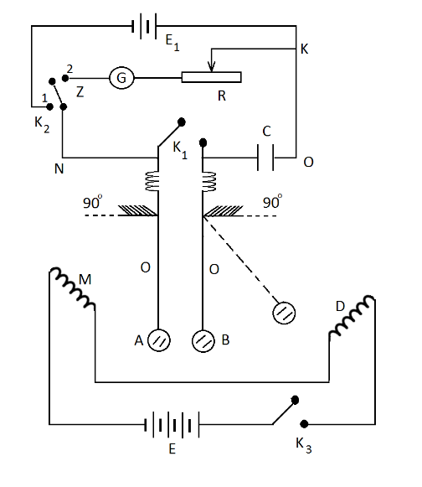
Considering the elastic collision of balls, and taking the system as a closed , we can calculate
the speed of the balls after the collision by applying the momentum and energy conservation laws. In an elastic collision of balls the force of collision depends on the mass and speed and on the values ​​characterizing the elastic properties of balls. The following installation is using to determine the time of collision. Steel balls A and B of equal masses are suspended on electricity conducting non-extensible threads. When they are in contact the circuit with the galvanometer G, resistance R and capacitor C connected in series is closed (Figure 1).
When key $К_{1}$is closed and the key $К_{2}$in position 2 by writing the equation of Ohm's law for NOKZ circuit, we obtain an expression for the time of collision
$t=\text{CR}\text{ln}\frac{q_{0}}{q_{0}−q}$
Fig. 1
Or
$t=2\text{.}3\text{CR}\text{lg}\frac{q_{0}}{q_{0}−q}$
where C - electrical capacitance of the capacitor, $q_{0}$- the initial charge on the capacitor, which passes through the galvanometer within one strike of balls.
Because the values on the galvanometer is proportional to the charge passing through it, we get the expression for the collision time
$t=2\text{.}3\text{CR}\text{lg}\frac{n_{0}}{n_{0}−n}$ (1)
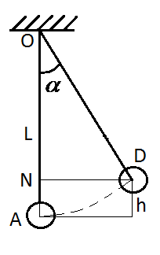
It is necessary to know the speed of the ball to determine the impact force. Suppose that a ball deflected by an angle $α$from its equilibrium position A, set aside to the D position, and then is raised to a height h (Figure 2). Returning to the equilibrium position at point A it gains the speed

$$υ=\sqrt{2\text{gh}}$$

As can be seen from the OND triangle
$$\text{cos}α=\frac{l−h}{l}=1−\frac{h}{l}$$Fig. 2
Hence we obtain for h:
$$h=2l{\text{sin}}^{2}\frac{α}{2}$$
Given this, an impact rate:
$ϑ=2\text{sin}\frac{α}{2}\sqrt{\text{gl}}$ (2)
If at the moment of collision, one of the balls was at rest, according to Newton's second law
$f⋅t=mϑ$ and $f=\frac{mϑ}{t}$ (3)
where f - the force of impact.

Procedure and analysis
1. Close the К₁ key using the key К₂, placing it in position 1, connect the current source Е₁ to the capacitor C (Figure 1). The capacitor will be charged.
2. Disconnecting the key К₁ place К₂ key in position 2, closing the condenser with a galvanometer ..
3. Closing the key К₁, determine the value on galvanometer n₀.
4. Remove key К₂ to 1 to charge the capacitor. Disconnecting К₁ move К₂ key to position 2.
5. Move the ball A to the electromagnet D and close the К₃ key.
6. Disconnecting the К₃ key, allow the ball A to move. At a meeting of balls A and B capacitor will partially discharged through the galvanometer. Note value on galvanometer n.
7. According n₀ and n calculated $t$ by the formula. (1).
8. Determine the angle $α$when the ball A is in front of the electromagnet D. Knowing this angle calculate $ϑ$by formula (2).
9. Knowing the mass$m$ of the ball, $ϑ$ and $t$, and using the formula (3) calculate the impact force.
10. By changing the position of the electromagnet, change the angle $α$and repeat the experience. Record the measurement results in the table and calculate the relative measurements error.

Measurement table.

№ | $$п_{0}$$ | $$п$$ | $$α$$ | $$t$$ | $ϑ$m/s | $$f\text{.}N$$
1
2
3

Questions to the lab. Newton's Laws. The law of conservation of momentum. The mechanical energy. Elastic and inelastic collision of balls.
Laboratory work # 6
DETERMINATION of the UNKNOWN FREQUENCY of OSCILLATION by BEATS.
Work Objective: To study the effect of interference of the same directed oscillations
Accessories: Two acoustic generators, oscilloscope.

Theory.
Consider the adding of two harmonic oscillations of the same direction, with slightly different frequencies. Denote the frequency of first oscillation ω₁ = ω, the second ω₂ = ω +Δ ω . The amplitudes of both oscillations will assume the same and equal to a. Since the oscillation frequency slightly different, we can always choose the origin of time, so that the initial phases of both oscillations be zero. Thus both the wave equation are as follows:
and
Adding these two expressions, and using trigonometric formula for the sum of cosines, we get:
$х=х_{1}+х_{2}=2а\text{cos}\frac{Δω}{2}t\text{cos}ωt$ (1)
(In the second factor we neglect the term$\frac{Δω}{2}$ in comparison with ω.)
As seen from the expression (1), the multiplier
(2)
is changing periodically with time, and it is the amplitude of the resulting oscillations. (Figure 1).
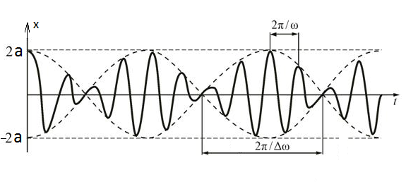

Fig. 1

Function (2) - is a periodic function with a frequency of 2 times the frequency of the expression under module mark. Hence:
$$\frac{Δω}{2}⋅T=\frac{\left(ω_{2}−ω_{1}\right)}{2}T=π$$
and
$$T=\frac{2π}{ω_{2}−ω_{1}}$$

At last
(3)

Thus, the frequency of amplitude pulsations - it is called beat frequency - equal to the difference between the frequencies of oscillations. Oscillations with pulsating amplitude are called beats (Figure 1).
Suppose that we need to determine the frequency of the source of unknown frequency . If we use a second source of oscillations with a certain frequency, varying over a wide range, it is possible to choose a frequency , close to so that the beat of frequency will be observed. By increasing the frequency of the second source we can again receive the beats with the same frequency f. But at this case , where is the frequency at second time.
From the last two equations we get
(4)

Installation diagram consisting of the oscilloscope EO and two generators, is shown in Figure 2. Generator $G_{x}$is used for forming oscillations of unknown frequency and the G respectively for oscillations of known frequency.

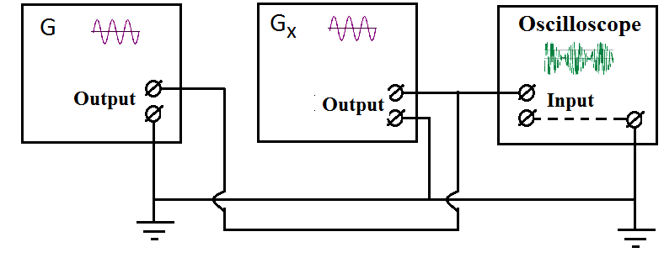

Fig.2

Progress.

- Connect both generators to the same input "X" of the oscilloscope. With the help of the "exit control" handle to reduce the voltage of generator's signal to zero. Switch on the Generator $G_{x}$for forming oscillations of unknown frequency. By adjusting the "Y" axis amplification of oscilloscope set the amplitude of the oscillations of an unknown frequency about 1.5 - 2 cm. Switch off Generator $G_{x}$then switch on the Generator G and set frequency about 10 kHz. Without changing the amplification of the oscilloscope by the "Output" handle of generator set the oscillation amplitude equal to the amplitude of oscillations of unknown frequency. Switch on the generator $G_{x}$.
- Set the frequency range on the oscilloscope at the level 5000 Hz. Changing the frequency of generator G in the range of 0,8 -12 kHz to get beats on the screen at first frequency .
- Turn the control knob of the generator and get on the screen next beats with the same beats frequency corresponding to the frequency . Use the formula (4) and these values to calculate the unknown frequency.
- Repeat the experiment several times. Calculate the relative measurement uncertainty.

Data table

№ | , Hz | , Hz | Hz
1
2
3

Questions to the laboratory work.
Harmonic oscillations, superposition of the identical directed oscillations. Beats.

LABORATORY № 7
DETERMINATION OF UNKNOWN FREQUENCY BY ADDITION MUTUALLY PERPENDICULAR OSCILLATIONS
Objective: To study the process of addition mutually perpendicular oscillations.
Accessories: The oscilloscope and two generators.
Works theory
The simplest vibrations are harmonic oscillations, ie, such fluctuations, in which the fluctuating value varies with time according to a sine or cosine law. Let us assume that a material point performs harmonic oscillations in two mutually perpendicular directions, which are described by the equations
$x=A_{x}\text{cos}ωt$ and $y=A_{y}\text{cos}(ωt+α)$ (1)
By addition of these fluctuations, we obtain the equation of the trajectory of motion of a material point. We obtain the equation of the trajectory
(2) by elimination of time $t$ from the equations (1)
$\frac{x^{2}}{A_{x}^{2}}+\frac{y^{2}}{A_{y}^{2}}−\frac{2\text{xy}}{A_{x}A_{y}}\text{cos}α={\text{sin}}^{2}α$ (2)
Equation (2) is the equation of an ellipse, and its axes are oriented with respect to the coordinate axes x and y arbitrarily.
When $α=0$ (the phase difference is zero), the equation (2) takes the form $y=\frac{A_{y}}{A}⋅x$ that is the equation of a straight line (Figure 1)
In the case of $α=±\frac{π}{2}$ the equation (2) becomes
$\frac{x^{2}}{A_{x}^{2}}+\frac{y^{2}}{A_{y}^{2}}=1$ (3)
ie in the equation of the ellipse, which half-axis is equal to the amplitudes of fluctuations (Figure 2). If $A_{x}=A_{y}=R$, then (2) goes to $x^{2}+y^{2}=R^{2}$, that is the equation of a circle with radius R.

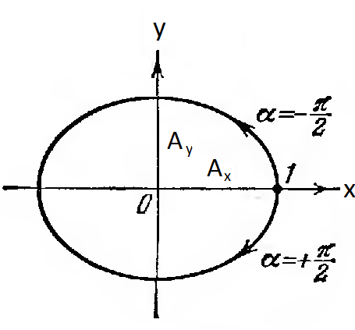
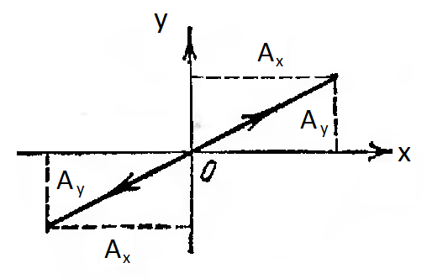

Fig. 2
Fig. 1

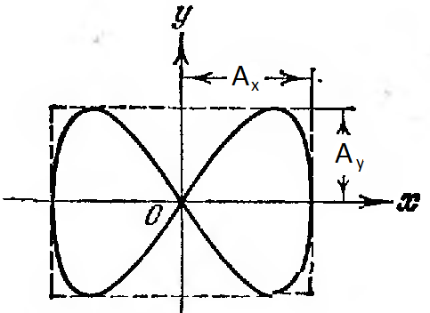
If the frequencies of perpendicular oscillations are not the same, the trajectory of the resulting motion is complex curves called Lissajous figures. Figure 3 shows one of them, when frequency ratio 1: 2 and the phase difference $\frac{π}{2}$.
Assume that the ratio of the oscillation frequencies is a rational number, and can be represented as a ratio of whole numbers $п_{х}$and $п_{у}$
Fig. 3
Then $п=\frac{п_{х}}{п_{у}}\frac{ω_{у}}{ω_{х}}=\frac{ν_{у}}{ν_{х}}=\frac{Т_{х}}{Т_{y}}$ (4)
Based on the equation (4) we can write:

$п_{х}Т_{у}=п_{у}Т_{х}=t_{1}$ (5)
This means that after doing $п_{х}$vibrations along the X-axis and $п_{у}$oscillations along the Y-axis during the time $t_{1}$ the point goes back to its original position. In the next period of time $t_{2}=t_{1}$ the oscillation is repeated again and we get a stable picture of the Lissajous figures that crosses arbitrary axis parallel to the x and y axes, respectively, $n_{x}$and $n_{y}$times. Using equation (5) we can calculate the unknown frequency $ν_{y}$using a known frequency$ν_{x}$.
$ν_{y}=\frac{n_{x}}{n_{y}}⋅ν_{x}Г_{х}$ (6)
Scheme of installation is shown in Figure 4. It consists of a generator $G_{х}$of known frequencies$ν_{х}$, oscilloscope EA and generator $G_{х}$of unknown frequencies$ν_{у}$.

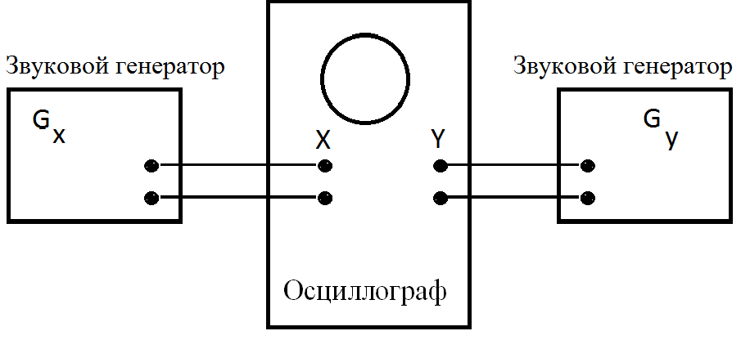

Fig. 4

Procedure and analysis
1. Assemble the circuit according to Fig. 4. Turn on the oscilloscope, to focus and bring the light spot in the center of the grid.
2. Turn on both the generator. Give to oscilloscope the frequency $п_{у}$from generator$G_{у}$. Turn the handle of the generator $G_{х}$frequency, to achieve the appearance of Lissajous figures on a screen.
3. Determine the number of intersections with the axes x $п_{х}$and y $п_{у}$, and calculate the unknown frequency $ν_{у}$by the formula (6).
4. Get another Lissajous figure by changing the frequency of the sound generator . Then, from the formula (6) re-calculate the required frequency$ν_{у}$.
Draw the resulting figures.

Measurement table.

№ | First Lissajous figure | Second Lissajous figure | Third Lissajous figure
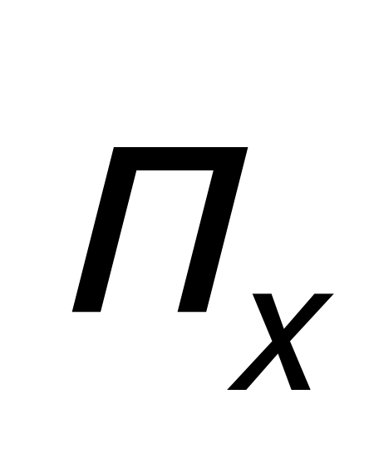
$$п_{у}$$
$ν_{х,}$Hz
$ν_{у,}$Hz

Questions to the lab. Simple harmonic oscillations, Addition of perpendicular oscillations. Lissajous figures.

LABORATORY № 8
DETERMINATION OF YOUNG'S MODULUS BY BENDING METHOD
Objective: The study of elastic deformation. Acquaintance with one of the methods to determine the Young's modulus.
Accessories: Device to determine the Young's modulus, caliper or micrometer, loads.
Works theory
Under the action of external forces bodies are deformed, i.e. their size and shape are changed . If after the termination of forces action the body takes the original size and shape, the deformation is called elastic.
Elastic deformation occurs in the event that the force which caused the deformation does not exceed a certain, specific to each individual body limit (known as the elastic limit).
If you exceed this limit, the body gains residual or plastic strains that persist even after the termination of the force on the body.
Within the elasticity the deformation obeys Hooke's law. If the rod with length $l_{0}$and cross section S under the force F is stretched by $Δl$, according to the law.
$\frac{F}{S}=E\frac{Δl}{l_{0}}$ (1)
where $\frac{F}{S}=σ$- the mechanical stress, $ε={Δl}/{l_{0}}$ - the relative strain, E - Young's modulus. Given these designations the Hooke's law can be written as
$σ=E⋅ε$ (2)

From (2) it follows that the Young's modulus is equal to normal stress when the relative strain is equal to one $ε=\frac{Δl}{l_{0}}=1$ ($Δl=l_{0}$and $l=2l_{0}$). Where $l$- the final length of the rod.
Young's modulus can be determined in several ways. One of these methods is a method of bending.
In a device the rod is located on two vertical supports that are on a solid plate (figure 1).
Two prisms arranged so that their edges are parallel and the distance between them is equal to L. There is a rod on prisms with the load F suspended in the center of it (figure 2).
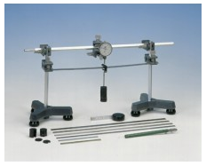
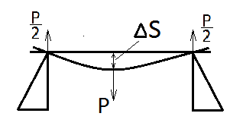
Fig. 2

Fig. 1

In this case, the bend of rod
$ΔS=\frac{1}{E}⋅\frac{{\text{PL}}^{3}}{4{\text{ab}}^{3}}$ (3)
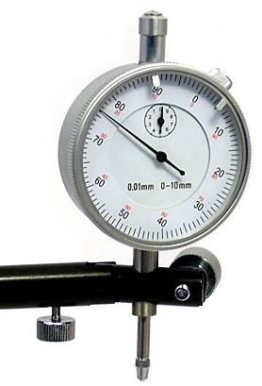
Where E - Young's modulus, $a$a is the width, $b$is the thickness, of L - the length of the rod. From this formula, we can calculate the numerical value of E.
$E=\frac{{\text{PL}}^{3}}{4{\text{ab}}^{3}ΔS}$ (4)
Bend of rod x is determined by "indicator". "Indicator" is showed on figure 3. Using this device we can determine the bend with accuracy of 10 mm. The revolution of huge arrow corresponds to 1 mm. Therefore, each division of the scale corresponding to huge arrow is 0.01 mm. Small arrow shows accuracy the bend up to 10 mm.
Fig. 3

Procedure and analysis
1. Measure the width and thickness of the rod, and also, placing the rod on the prisms (the ends of the rod should equally extend beyond the prisms), measure the distance between the prisms.
2. Mark the indication of the indicator by placing various loads on the suspension in the middle of the rod.
3. Calculate the deviation (x) for each weight from expression (4).
4. Repeat the experiments for each load several times. Calculate the relative error according to the results obtained from the experiments.

Measurement table

№ | L, m | a, m | b, m | F, N | x,m | E, Pa
1.
2.
3.

Questions to the lab. Deformation of rigid bodies. Hooke's Law. Stress diagram.
Laboratory Work # 9
Determination of Cp/Cv ratio by speed of sound in gas

Work Objective: To study methods to measure specific heats of gases.
Accessories: Oscilloscope, a sound generator, a microphone and a tube connected to the phone.
Short theoretical information

From acoustic known that the sound speed v in the elastic medium with a density ρ defined by the relation
$υ=\sqrt{\frac{1}{\text{αρ}}}$ (1)

where α - the coefficient of elasticity of the medium. Considering the relationship between α and the gas pressure P in the form of $α=\frac{1}{γP}$ the formula for velocity may be written as
(2)
where γ = Cp/Cv - is polytrophic (adiabatic) index and equal to the ratio of molar specific heats of the gas at constant pressure and volume. From the ideal gas law for density we can get
(3)
Substituting (3) into (2) for the speed of sound in the gas we get
$υ=\sqrt{\frac{γ\text{RT}}{M}}$ (4)
and $γ=\frac{{Mυ}^{2}}{\text{RT}}$ (5)
where R- universal gas constant, M is the molar mass, T the absolute temperature.
Hence for determining the ratio of specific heats it is necessary to know the temperature and the speed of sound in the gas. The oscillations of sound source excited in an elastic medium, due to the interaction between neighboring particles are transferred to other particles and thus the propagation of oscillation at a certain speed occurs in environment. This process is called the wave process or simply wave.
The particles of the medium in which the wave propagates, are not transferred by the wave, they only oscillate about their equilibrium positions. Depending on the direction of oscillations of the particles with respect to the direction of wave propagates, there are two kinds of wave: longitudinal and transverse waves. In a longitudinal wave, particles of the medium oscillate along the direction of wave propagation. In the transverse wave medium particles oscillate in the perpendicular direction to the wave propagation. Sound waves in liquids and gases are longitudinal, and in solids medium - both longitudinal and transverse.
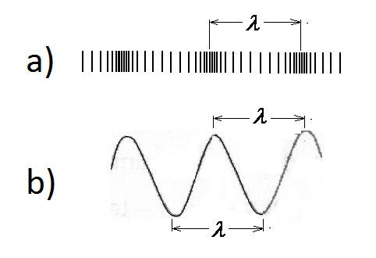
When the sound passing through air the alternating compression and rarefaction regions of particles are created and moving in the direction of propagation of the oscillations with speed v. The distance between the two nearest points, oscillating in the same phase, called the wavelength λ. In the longitudinal wave it equal to the distance between the centers of two neighboring compressions or rarefactions of particles (Figure 1a), and in a transverse wave between adjacent crests or troughs (Figure 1b)

Figure 1.

If sound wave faces with some barrier on its path the wave is reflected in the opposite direction. The incident wave and the reflected wave superimposed on each other and form a standing wave. The points where the amplitude of oscillation of standing wave becomes zero are called nodes. Points where the amplitude of oscillation reaches a maximum value are called antinodes of a standing wave. All points between two adjacent nodes, oscillate in phase (i.e., in the same phase). Points which lie on opposite sides of the node oscillate in antiphase.

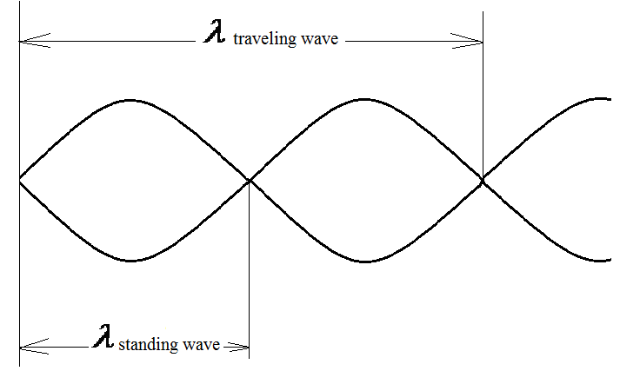
Figure 2
As seen from Figure 2, the distance between neighboring nodes, as well as the distance between neighboring antinodes is equal to λ/2, where λ - the sound wavelength. That is, the length of the standing wave will be equal
(6)
As it is known, the speed v of the wave of frequency f determined by the formula
v= λ∙f (7)

Taking into account expression (6) in (7) we have:
(8)

Hence, to determine the velocity of sound in the medium is necessary to know the length of the standing wave and the frequency of sound.
If the sound waves propagate in a medium in the direction of the x-axis, arising here standing wave described by the equation
$ξ=2a\text{cos}\frac{2πx}{λ}\text{cos}ωt$

$A=\left|2a\text{cos}\frac{2πx}{λ}\right|$where

the amplitude of the standing wave.
$\frac{2πx}{λ}=±πn$
At points where (n=0,1,2,3...) the oscillation amplitude reaches a maximum value 2a.
These points are called antinodes of a standing wave. From the condition of maximum coordinates of antinodes can be obtained
(9)
Thus, determining the position of the antinodes of the standing wave, it is possible to calculate the length, and then the speed of the sound wave.

Installation Description

Installation diagram is shown in Figure 3. Sound head T connected to the sound generator produces sound waves of known frequency. These sound waves propagating in the sliding metal tube, caught by microphone M.
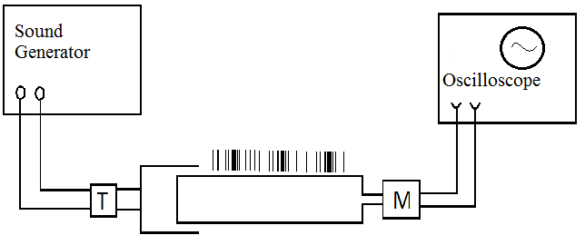
Figure 3

Arising in the microphone M audio signal is observed on an oscilloscope connected to microphone. Telephone and a microphone connected to the metal sliding tube by a thin rubber tubing. Sound vibrations created by phone, traveling in the tube and are reflected from the opposite end. If the tube fits a whole number of half-waves, they are superimposed and form a standing wave. There are two ways to get a standing wave in the tube:
1) by changing the frequency of the generator of acoustic vibrations
2) by changing the length of the tube
In this work we use the second method.
Using the condition (9) the value of x_{max} and the corresponding value of λ are determined. On the basis of (7) and (5) the speed v and the ratio of specific heats γ are calculated.

The work progress
- Assemble the installation according to the diagram on Figure 3, connect oscilloscope and sound generator to the AC power supply. Give them 5-6 minutes to warm up.
- Connect sound head T to the output terminals of the sound generator and the microphone to the vertical input of an oscilloscope, and to ensure that the picture on the screen looked like stable sine wave. Adjust frequency of the sound generator, so that on the oscilloscope observed oscillations of sufficient amplitude. By varying the length of the sliding tube to achieve obtaining several consecutive stable sinusoidal patterns with maximum amplitude.
- At the moment of obtaining the maximum amplitudes stop to sliding of the tube and measure their positions X according to the divisions marked on them.
- According to the value of X calculate the λ value by the formula (9).
- Knowing the λ, calculate the speed of sound by formula (7) and according to formula (5) to calculate the γ.
$γ=\frac{i+2}{i}$According to the formula

calculate the number of degrees of freedom i.
- Repeating the experience for different sound frequencies to calculate the absolute and relative measurement error.

Data Table

№ | f, Hz. | X₁, m | X₂, m | λ_{stand}, m | λ, m | γ | i
1.
2.
3.

Questions for laboratory work.
The wave process. Wave equation. Standing waves. The specific heat of an ideal gas at constant pressure and volume, their relationship with the number of degrees of freedom.

LABORATORY № 10
DETERMINATION OF THE RATIO OF HEAT CAPACITIES OF GASES BY CLEMENT – DESORMES METHOD
Objective: Learning the method of Clement - Desormes - determination of the ratio of heat capacities of gases and the determination of this ratio for air.
Accessories: Glass bottle with capacity of 5 - 6 cubic meters, manometer, air pump.
Works theory
A physical quantity which is numerically equal to the amount of heat which must be transmitted to 1 kg of body weight in order to change its temperature by 1 ° C, is called the specific heat of a substance (c). Physical quantity that is numerically equal to the amount of heat that is necessary to transmit to one mole of a substance to change its temperature by 1 ° C, is called the molar heat capacity of the substance (C). If the molar mass of a substance is equal to M, the relationship between the molar and specific heat capacity is described by
С=Мс (1)
The relationship between the specific heat at constant pressure (c_{p}) and volume (c_{v}) with the molar heat capacity at constant pressure (Cp) and volume (CV) is similar to the expression (1), ie,
C_{v} = M c_{р} and C_{V} = M c_{V} (2)

If the gas is heated at constant volume, all the amount of heat goes to increase its internal energy. When heated, the gas at a constant pressure one part of the supplied heat goes to increase its internal energy, a part - to perform work on the gas expansion. Therefore, Cp> Cv. These heat capacities are related to the number of degrees of freedom (i) of molecules with the following relationships:
$C_{v}=\frac{i}{2}R$$c_{v}=\frac{i}{2}\frac{R}{M}$$C_{p}=\frac{i+2}{2}R$$c_{p}=\frac{i+2}{2}\frac{R}{M}$
(3)

From these relations can be seen that Cp = Cv + R, where R - universal gas constant.
The number of degrees of freedom of a mechanical system is the number of independent variables, with the help of which can be set the position of the system. Taking into account the expression (3) we obtain for the ratio of heat capacities:
$γ=\frac{C_{p}}{C_{v}}=\frac{c_{p}}{c_{v}}=\frac{i+2}{i}$
(4)

Measurement of specific heat capacities of gas, and in particular at a constant volume seems difficult. To do this, we need to fill the certain volume container with a gas. Because this mass of gas is much less than the mass of the container, the amount of heat required for heating the gas is many times smaller than the quantity of heat required for heating the cylinder. Therefore, the amount of heat received by gas is less than the error of experience. In the measurement of the specific heat at constant pressure С_{р}, the heated gas passing through a coil placed in the calorimeter at constant pressure, gives a certain amount of heat to calorimeter. Undoubtedly, in this case the mass of gas passed through the coil must be greater than the mass of the coil, and the measurement of С_{р} will be more accurate. In order to solve a number of physical problems it is necessary to know the value of the ratio of specific heats $γ$. On the other hand, if it is known $γ$, we can calculate С_{р} from experience, and then С_{V} calculate. One of the methods of determination the ratio ${C_{p}}/{C_{v}}$ is the method by Clement - Desormes.

Description of installation .
Installation diagram is shown in Figure 1.
A gas can be pumped into the glass balloon with a capacity of 15 - 20 liters by the pump, in particular an air under pressure Р₁. The difference between Р₁ and Р₀ (atmospheric pressure) is fixed by manometer M coupled with the balloon.

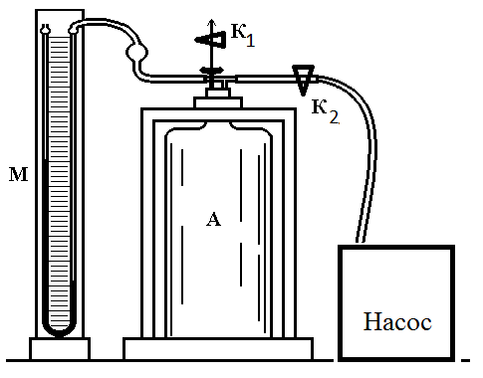
PUMP
Fig. 1

If $h_{1}$- the difference in liquid level in manometer, expressed in units of pressure, then
P₁=P₀+h₁ (5)
Compressed in a cylinder to a pressure Р₁ gas is heated, but after some time, due to the thermal conductivity of the material of the vessel, it becomes equal to the ambient temperature. At this point, valve К₁ is quickly opened and closed, which leads to the adiabatic expansion of gas.
The volume of gas is equal to the volume of the vessel V at pressure Р₁. After opening the tap К₁, the gas partly exits to the tube of manometer, and partly remains in the balloon. Obviously, the gas pressure on both parts are equal atmospheric. The volume of the gas $V_{1}$becomes equal to the sum of the volumes V, of gas remaining in the balloon, and the volume of gas that is outflowed from the balloon$V_{2}$
$V_{1}=V+V_{2}$
As noted above, when opening the tap К₁, the adiabatic expansion of the gas takes place, whereby the gas in the cylinder is cooled below room temperature. Thus the gas moves from the state (Р_{1,}V ) to the state of (Р₀, V₂). If we close the valve К₂, after some time the gas in balloon has reached room temperature, whereby the pressure Р₂ becomes higher than the atmospheric pressure. The difference between Р₀ and Р₂ is equal to the difference in height h₂ of fluid in manometer M.
$P_{2}=P_{0}+h_{2}$ (6)
Ultimately, the gas pressure becomes Р₂ and the volume V₁. Because the temperature and the mass of gas remained the same at the beginning and the end of the experiment , the process can be considered isothermal and can be described with the Boyle - Mariotte equation :
P₁V= P₂V₁ (7)
The adiabatic expansion from the state (Р₁, V) to the state (Р₀, V₁) is described by the Poisson equation
$P_{1}V^{γ}=P_{0}V_{1}^{γ}$ (8)
Raising the degree of the equation (7) by $γ$ and dividing it by the equation (8), we obtain:
$\frac{P_{1}^{γ}}{P_{1}}=\frac{P_{2}^{γ}}{P_{0}}$
Taking the logarithm of this expression:

$$γ\text{ln}P_{1}−\text{ln}P_{1}=γ\text{ln}P_{2}−\text{ln}P_{0}$$

And for $γ$ :
$γ=\frac{\text{ln}P_{1}−\text{ln}P_{0}}{\text{ln}P_{1}−\text{ln}P_{2}}$ (9)

Because the difference (Р₁ –Р₀) and (Р_{1,} Р₂) has very small values, then with a small error the quation (9) can be rewritten as
$γ=\frac{P_{1}−P_{0}}{P_{1}−P_{2}}$ (10)
If we substitute the values ​​of Р₁ and Р₂ from the formulas (5) and (6) to the formula (10), we obtain
$γ=\frac{P_{0}+h_{1}−P_{0}}{P_{0}+h_{1}−(P_{0}+h_{2})}=\frac{h_{1}}{h_{1}−h_{2}}$ (11)
Procedure and analysis
1. The air is blown in to the balloon with the pump through the tap К₂ until the fluid level difference becomes equal to 10-15 cm. Then close the tap К₂ and note in a few minutes the established difference in liquid levels in the manometer h₁.
2. Open the tap К₁ and close quickly when there is the equality of fluid levels in the manometer. Wait 2-3 minutes and after the gas temperature reaches room temperature, write h₂ from manometer.
3. Substituting numerical values ​​ h₁ and h₂ in the formula (11), calculate the value $γ$.
4. Repeat the experience 8-10 times, calculate the mean value of $γ$, absolute and relative experimental error.

Measurement table.
№ | h₁, sm | h₂, sm | $$γ$$ | i
1.
2.
3.
..
10

Questions to the lab. Adiabatic process and isoprocesses. Poisson equation and the consequences from it. The internal energy and heat capacity of an ideal gas.
Laboratory Work # 11
Determination of viscosity of liquids by Stokes's method
Work Objective: Study of basic laws of motion of viscous fluids and empirically determination of the coefficient of internal friction.
Accessories: Investigated liquids, beaker, an aqueous solution of copper sulfate, stopwatch, accurate scales and weights.

Short theoretical information

When fluid flow friction occurs between its adjacent layers as they slide past one another. This force is called the internal friction or viscosity of the fluid. The higher internal friction forces, the higher viscosity of the fluid and the greater the fluid behavior deviates from the ideal. Newton found that the friction force between the fluid layers is described by the following equation:
$F_{f}\text{=}η(\frac{v}{Δx})ΔA$ (1)
where ΔA- the contact area between the layers, $\frac{v}{Δx}$ - the velocity gradient is equal to the change in the velocity with position as measured perpendicular to the direction of velocity, η- the internal friction coefficient which characterizes fluid viscosity, and depends basically on the kind of liquid and temperature. Coefficient of internal friction (viscosity) is equal to the frictional force acting on a unit area parallel to the layers if velocity gradient equal to one unit.
The SI unit of η is: [η] = Pa∙s.
Viscosity of fluids can be calculated in various ways, one of which is the method of Stokes. This method is based on the occurrence of friction forces when solid body moving within the liquid. Stokes found that the force depends on the size and shape of the body, the speed of the body in fluid, and on the viscosity of the fluid. In particular, the friction force at low velocities of motion of the ball of r radius inside the liquid is given by:
$F_{St}\text{=}6πηrυ$ (2)
When the ball moves in a liquid gravity force W, the force of internal friction (drag force) and the Archimedes's buoyant force are acting on it. (Fig.1). In this case, the equation of a ball motion is described as:  ma = W - F_{St} - F _{buoyant} (3) | 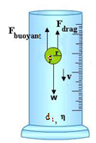  Figure 1

Ball drop in the fluid is accelerated only at the very beginning of the motion, then became to be uniform because friction force increases with increasing of velocity and together with the Archimedes buoyancy force balances the force of gravity W. From that moment the ball will move uniformly with terminal speed and equation (3) can be written as:
W - F_{St} - F_{buoyant} = 0 (4)
Archimedes force is equal to the weight of the liquid in the volume of the ball (F_{buoyant} = W₁). Considering this we can write:
W - W₁ = F_{St} (5)
where $W \text{=} mg \text{=}\frac{4}{3}πr^{3}dg$ and $W_{1} \text{=} m_{1}g \text{=}\frac{4}{3}πr^{3}d_{1}g$
are the weight of ball and discharged liquid respectively. d - density of the ball, d₁ - density of the liquid. Equation may be rewritten in form:
$\frac{4}{3}πr^{3}g\left(d\text{-}d_{1}\right)\text{=}6 πηrυ$ (6)
or
$η\text{=}\frac{2(d\text{-}d_{1})gr^{2}}{9}$ (7)
By using equation (7) may be calculated the viscosity of the sample liquid.
As the ball drops may be used an aqueous solution of copper sulfate, which takes shape with lower surface if it drops in another liquid, i.e. spherical shape. The radius of the drop is determined indirectly by weighing. To do this, measure the mass M of the "n" drops, then the mass of a single drop is
$$m\text{=}\frac{M}{n}\text{=}\frac{dV}{n}\text{=}\frac{4}{3}πr^{3}d$$
and
$r\text{=}\sqrt[3]{\frac{3m}{4πd}}\text{=}\sqrt[3]{\frac{3M}{4nπd}}$ (8)
Thus, by substituting radius of the ball from expression (8) in (7), we can calculate the coefficient of viscosity of the liquid.
Description of Installation
Experimental setup is shown in Figure 2. As a sample liquid can be taken vegetable oil. Oil is poured into the cylindrical vessel C with deposited on it and ring marks a and b. A solution of copper sulfate is poured into a dropping glass C₁ located above the container C. From the pipette D solution drop falls in a container C, and by stopwatch we measures time of falling of the drop between the marks a and b. Knowing the time, are calculated the terminal speed of the falling drop. | 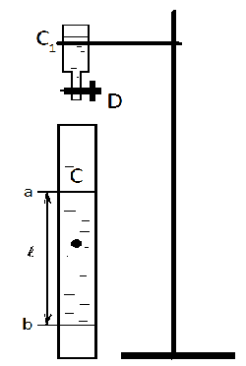  Figure 2
The progress of work
- Immersing a drop of copper sulfate solution in a vessel using a D pipette, followed it movement. At the moment of achieving of drop the mark (a) start the stopwatch and stop it at the moment of drop reaching the mark (b). Knowing the time of fall t between the marks (a) and (b) and the distance l between them, calculate the speed of drop fall.
- Calculate the radius of the drop. For this measure mass m₂ of carefully dried cup on a balance. Placing cup under the dropper, drip into it 50-60 drops of the solution and measure the mass of the glass with solution m₃. Thus mass of solution will be equal to the M = m₃ - m₂. Knowing the number of solution n and their M mass, calculate the drop radius r by the formula (8).
- Based on the data v and r according to formula (7) calculate the value η (values of d and d₁ are available in the laboratory).
- Repeat experience 3 times, calculate absolute and relative experimental error.
Data Table
№ | l, m | v,m/s | t, s | m₃, kg | m₂, kg | m₁, kg | m, kg | η, Pa∙s
1
2
3

Questions for laboratory work.
Mechanics of fluids, equation of continuity and Bernoulli's equation. Ideal and viscous liquids. Laminar and turbulent fluid flow. The Reynolds number. Stokes formula.

LABORATORY № 12
DETERMINATION OF THE COEFFICIENT OF INTERNAL FRICTION OF A LIQUID ACCORDING TO THE POISEUILLE LAW
Objective: Acquaintance with the main regularities of the motion of viscous liquids and the determination of the coefficient of internal friction by an experimental method.
Accessories: Viscometer, stopwatch, pycnometer, distilled water, test liquid, scales and weights.
Works theory
One of the methods for determining the coefficient of internal friction of a liquid is based on the Poiseuille law. According to this law, the volume of liquid laminarly flowing through the capillary tube is determined by the formula:
$V=\frac{{πr}^{4}\text{Pt}}{8ηl}$
(1)

Here $r$ is the radius of the tube, $l$ its length, P is the pressure exerted on the moving fluid, and V is the volume of liquid flowing out of the tube during time t. From here
$t=η\frac{8\text{lV}}{{πr}^{4}P}$

If we take the same volumes of two different liquids, then depending on the coefficient of internal friction, the time of the outflow of these liquids through the same tube will be different, namely:
$t_{1}=η_{1}\frac{8\text{lV}}{{πr}^{4}P_{1}}$$t_{2}=η_{2}\frac{8\text{lV}}{{πr}^{4}P_{2}}$

and

From the last two relations we have:
$\frac{t_{1}}{t_{2}}=\frac{η_{1}}{η_{2}}\frac{P_{2}}{P_{1}}$
(2)

If the heights of the columns of liquids are the same and equal to h, then the pressures and are respectively equal to:

$P_{1}=ρ_{1}\text{gh}$ and $P_{2}=ρ_{2}\text{gh}$

Where $ρ_{1}$and $ρ_{2}$ density of liquids. Substituting $P_{1}$ and $P_{2}$$\frac{t_{1}}{t_{2}}=\frac{η_{1}}{η_{2}}\frac{ρ_{2}}{ρ_{1}}$ values ​​of into the equation (2), we obtain

$η_{1}=η_{2}\frac{ρ_{1}}{ρ_{2}}\frac{t_{1}}{t_{2}}$From here
(3)
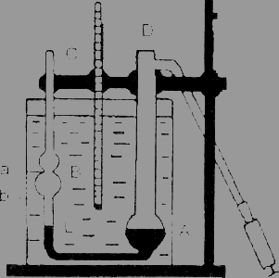
Обычно в качества эталонной жидкости берут дистиллированную воду. Поэтому в
уравнении (3) $ρ_{2}$ - плотность воды, $t_{2}$- время её истечения, $η_{2}$- коэффициент внутреннего трения воды.
To determine the coefficient of internal friction, the Ostwald viscometer is used. This viscometer is a U - shaped tube DABC (Fig. 1). The tube has spherical extensions A and B, connected to each other by a capillary L. The expansion volume A is usually 3-5 cm3. The spherical expansion B is provided with two marks a and b, which allow one to determine the times of the expiration of equal volumes of liquids. To maintain a constant temperature during the experiment, the viscometer is placed in a thermostat.
Fig. 1

Procedure and analysis
- Thoroughly wash the viscometer with the liquid to be tested, then fill the extensions A and B with this liquid so that its level is slightly higher than the mark a.
- By opening the hole D, allow the liquid to flow out of the expansion B. At the moment of passing the liquid through the mark a turn on the stopwatch, and at the moment of passing the mark b, stop the stopwatch. Note down the stopwatch data. Experience repeating 3-5 times.
- Repeat the same experiment with water. Determine the time of the outflow of water.
- Determine the density of water and liquid. Knowing the coefficient of internal friction of water, according to formula (3), calculate the coefficient of internal friction of the liquid being studied.
- Repeat the experiment 3-4 times and calculate the absolute and relative errors of the experiment according to the results obtained.

Measurement table.
№ | $t_{1}$, s | $t_{2},s$ | $η_{2},\text{Pa}⋅s$ | $$ρ_{1},{\text{kg}}/{m^{3}}$$ | $$ρ_{2},{\text{kg}}/{m^{3}}$$ | $$η_{1},\text{Pa}⋅s$$
1.
2.
3.

Questions to the lab. Mechanics of liquids. Ideal and viscous liquids. Laminar and turbulent flow of liquids. Reynolds number. The Poiseuille formula.

LABORATORY № 13
DETERMINATION OF THE SURFACE TENSION OF A LIQUID BY DROP METHOD
Objective: Studying the phenomenon of surface tension in liquids and the experimental determination of the surface tension.
Accessories: Drip, analytical balances and weights, a glass, a micrometer or caliper.
Works theory
The force of the interaction between the molecules of the fluid decreases very rapidly with increasing distance between them. Therefore, each molecule interacts with the molecules which are located at some distances from it. The sphere within which the molecule can interact if it is situated in the center of it is called the sphere of molecular action.
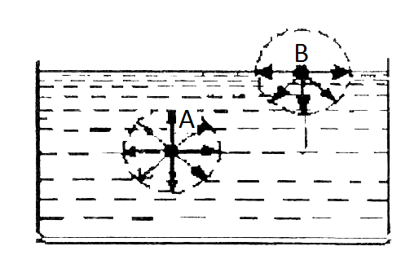
Consider a molecule A, located inside the liquid so that the sphere of its molecular action is entirely inside the liquid (Figure 1). The forces acting on this molecule from other molecules, in average balance each other. Therefore, the role of forces of the molecular action under these conditions is to regulate the distance between the molecules.
The conditions of molecules located in the surface layer of the liquid are completely different . Part of the sphere of molecular action is out of the liquid. Since the liquid density much greater density of
Fig. 1
the liquid vapor, the concentration of molecules in the part of the
sphere, located above the liquid surface, much less than the concentration of molecules in the rest of the sphere. As a result, from the liquid on the molecule B, and also on all the molecules which are located inside the liquid at a distance equal to the radius of the molecular action from the liquid surface the forces directed inside the liquid are acting which are many times greater than the forces exerted by the molecules of vaporized liquid . Thus, the molecules on a surface layer exert on the whole liquid the pressure, called molecular pressure. Each molecule in the transition from the lower layers to the surface layer must perform the work against the pressure of molecular forces. This leads to an increase in its potential energy. Therefore, the potential energy of the molecules of the surface layer is greater than the energy of the molecules of the underlying layers.
The free energy of the molecules of the surface layer is also greater than the energy of other molecules, but the average kinetic energy of all the molecules of the liquid are the same (free energy is equal to the difference between potential and kinetic energy).
It is known that the equilibrium position corresponds to the minimum of the potential energy. The liquid left to itself, will take the form of a minimal surface, that is, surface cutting will take the form of a ball. This phenomenon is called surface tension. The surface tension of liquids characterized by the coefficient of surface tension. Surface tension factor is the free energy per unit surface of the liquid or surface tension force per unit length of any line drawn on the surface of the liquid, i.e.
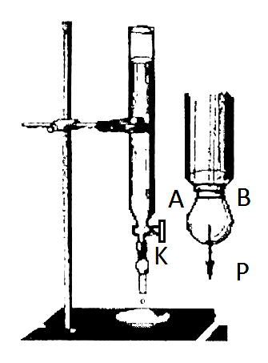
$σ=\frac{\text{ΔΕ}}{ΔS}=\frac{F}{l}$

There are several methods for measuring the surface tension. One method is the drop one.
The liquid flows from the narrow tube drop by drop, which before the separation of the capillary have the form shown in Figure 2.
Assume that the outer radius of the tube is equal to R. The drop can break away from the tube only under certain conditions. There are two oppositely directed forces acting at a drop. The force of gravity and the force that holds drop - the force of surface tension. Drop off from the tubes when gravitational force becomes equal to the force of surface tension, ie, $p=2πxσ$ here p-drop weight (p = mg) $σ$- coefficient, $r$- neck radius AB.
Fig. 2
Experience shows that the glass tubes with a wall thickness of 1 mm neck radius $r$and the outer radius of the tube R are related by: $r=0,\text{62}R$
Thus, we obtain:
$\text{mg}=2πrσ=0,\text{62}⋅2πRσ$
Hence, obtain the expression
$σ=\frac{\text{mg}}{0,\text{62}⋅2πR}$ (1)
where $m$- the mass of a single drop. Thus, for calculation it is the need to know the magnitude of the inner or outer radius of the tube and one drop weight.

Procedure and analysis
1. Determine the mass $m_{1}$of thoroughly cleaned and dried cup using an analytical balance.
2. Set the tap K (Figure 2) in a position to be able to count the number of falling liquid droplets from a tube . Putting a glass under the pipe, drip into it $n=\text{90}−\text{100}$ liquid droplets.
3. Measure the mass $m_{2}$of the cup with liquid.
4. Determine by the formula $m_{2}−m_{1}$ the mass of the liquid in the cup.
5. Determine the mass of a single drop by formula $m=\frac{m_{2}−m_{1}}{n}$
6. Measure the outer radius of the tube using a micrometer or caliper.
7. According to data obtained by the formula (1) calculate the value $σ$.
8. Changing the number of drops each time, repeat the experiment 3-5 times. Find the average value $σ$. Calculate the absolute and relative error experience.

Measurement table.
№ | m₁, kг | m₂ , kг | m₃, kг | m, kг | R, m | $σ$,Н/m
1.
2.
3.

Questions to the lab. Surface tension. Wetting phenomenon. Capillarity.

LABORATORY № 14
DETERMINATION OF THE AVERAGE FREE PATH LENGTH AND THE EFFECTIVE DIAMETER OF AIR MOLECULES
Objective: The experimentally study of methods for determining the average free path length and the effective diameter of air molecules.
Accessories: capillar and a glass jar with a tap, a stopwatch, beaker, ruler.
Works theory
$\bar{λ}=\frac{1}{\sqrt{2}{\text{πσ}}^{2}n}$Gas molecules, being in thermal motion continuously collide with each other. During the time between two successive collisions gas molecule passes some way, which is called the mean free path. The mean free path is the value determined by the expression:
(1)

where $σ$- the effective diameter of the molecule, $n$ - the concentration. The value $σ$can be found using Poiseuille's law, according to which the volume of liquid, laminar flowed over time $t$ through a capillary tube radius and length $l$$V=\frac{{πr}^{4}\text{Pt}}{8ηl}$, defined by the formula

(2)

where $P$ - the pressure exerted on a moving fluid, $η$ - viscosity of liquid. On the other hand according to the molecular-kinetic theory the internal friction coefficient is
$η=\frac{1}{3}ρ\bar{υ}\bar{λ}$
(3)

where $\bar{ϑ}$ - the average speed of the thermal motion of the molecules, and$ρ$- the gas density is determined by the formula
$ρ=\frac{\text{pM}}{\text{RT}}$
(4)

Substituting in the formula (3), we have:
$η=\frac{1}{3}\frac{\text{PM}}{\text{RT}}\bar{υ}\bar{λ}$
(5)

where $R$- the universal gas constant, $T$- the absolute temperature, $M$- the molar mass of the gas.
Taking into account $η$ in the formula (2) we get:
$η=\frac{1}{3}\frac{\text{PM}}{\text{RT}}\bar{υ}\bar{λ}$(6)

$\bar{υ}=\sqrt{\frac{8\text{RT}}{πM}}$
where (7)

Substituting this expression in (6) and determine the average free path length

$\bar{λ}=\frac{3{πr}^{4}tΔP}{\text{16}\text{PVl}}\sqrt{\frac{π\text{RT}}{2M}}$

(8)

Thus, by calculating $\bar{λ}$with the equation (8), from the formula (1) the numerical value for the effective diameter of the molecule can be found
$σ=\frac{1}{\sqrt{\sqrt{2}πn\bar{λ}}}$
(9)

The concentration of gas molecules $n$ can be determined as follows. According to the basic equation MKT for normal conditions, $P_{0}=n_{0}{\text{kT}}_{0}$ and for an arbitrary state $P=\text{nkT}$. From these two relations

$n=n_{0}\frac{{\text{PT}}_{0}}{P_{0}T}$ (10)
where $n_{0}=2,3⋅{\text{10}}^{\text{25}}$$м^{−3}$ - the number of Loschmidt, $T_{0}=\text{273}K$ and $P_{0}=1,\text{013}⋅{\text{10}}^{5}$$\text{Па}$. Substituting (10) into (9), the effective diameter

$σ=\frac{\sqrt{P_{0}T}}{\sqrt{\sqrt{2}{πn}_{0}{\text{PT}}_{0}\bar{λ}}}$
(11)

Installation, procedure and analysis.
To perform the work the installation shown in Figure 1 is used
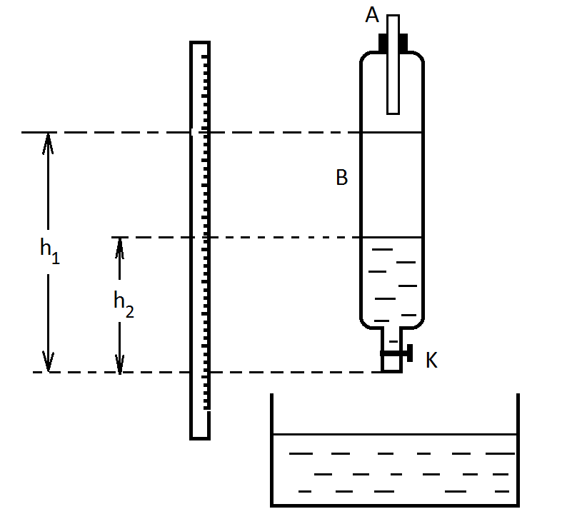

Fig. 1

1. Fill the container В with water and measure the height $h_{1}$of the liquid column.
2. Open the tap $K$and simultaneously start the stopwatch. Measure the flow time $t$when filling the cup with 200 - 250 см³ of water,
3. Measure the volume of leaked water (it is equal to the volume of air passing through the capillary A.)
4. Measure the height of the water column $h_{2}$$ΔP=\frac{h_{1}+h_{2}}{2}ρg$ after the water outflow, and using the following formula calculate the pressure difference

5. Knowing the value of atmospheric pressure $P$and temperature $T$calculate by the formulas (8) and (11) numerical values $\bar{λ}$, and $σ$ respectively.
6. According to the results calculate absolute and relative experimental error.

Measurement table.
№ | P, Pa | T, K | t, s | h₁, m | h₂, m | V, m³ | $ΔP$,Pa | $\bar{λ}$,m | $σ$,m
1.
2.
3.

Questions to the lab. The main equation of MKT. The average free path of the molecules. Poiseuille’s formula.
Laboratory Work # 15
Determination of the Boltzmann constant
Work Objective: Studying the ideal gas law, the experimental determination of the Boltzmann constant.
Accessories: Glass container of 5-10 liters, a medical syringe, manometer, indoor thermometer, ether.
Short theoretical information
The state of gas is characterized by state parameters: pressure P, volume V, and temperature T. The equation relating the parameters of state of an ideal gas is called the equation of state or Chaperon - Mendeleev equation:
$\text{PV}=\frac{m}{M}\text{RT}$ (1)
where m - the mass of the gas, M - molar mass of the gas, and R - universal gas constant. Universal gas constant shows how much work will be done for isobaric expansion of 1 mole of gas when heating it to 1 K.
The ideal the gas, which neglected the forces of intermolecular interaction and its own volume of molecules. Ideal gas molecules behave as a completely elastic balls is therefore considered that the molecules possess only ideal gas kinetic energy value for each molecule of which is:
The gas of neglected forces of intermolecular interaction and own volume of molecules is called the ideal gas. Ideal gas molecules behave as a completely elastic balls. Therefore considered that the molecules of ideal gas possess only kinetic energy which value for each molecule is:
(2)
where i - number of degrees of freedom of the molecule (the number of independent coordinates defining the position of molecules in space), k - Boltzmann constant, associated with the universal gas constant by the following relation:
$k=\frac{R}{N_{A}}$ (3)
N_{A} - Avogadro number, indicates how many molecules contained in one mole of any gas. The physical meaning of the Boltzmann constant is that constant k shows how much work is done by each molecule in the process of isobaric expansion gas for increasing its temperature by 1K.
Substitute the Boltzmann constant in the equation (1) and obtain
$$\text{PV}=\frac{m}{M}N_{A}\text{kT}$$
Or if we note that $n=\frac{{\text{mN}}_{A}}{\text{MV}}$- is a concentration of atoms we get:
$p=\text{nkT}$ (4)
From equation (4) it follows that the ideal gas pressure at a given temperature is determined by the number of molecules per unit volume (concentration of molecules), and does not depend on the type of gas. If there is a mixture of gases such as air in this job (a mixture of mainly oxygen and nitrogen) the pressure is equal to:
(5)
wherein $n_{1,}n_{2},$etc. represent the concentration of molecules of the first, second, etc. gas kinds of.
Expression (5) can be represented as:
$P=n_{1}\text{kT}+n_{2}\text{kT}+\text{.}\text{.}\text{.}$ (6)
where$n_{1}\text{kT}$ - is the pressure in the vessel if there were only first kind molecules, $n_{2}\text{kT}$- is the pressure that would be in the presence only the second kind of molecules in the vessel, etc.
The pressure due to molecules of any one kind, provided that they only one are present in the vessel in quantities in which they are contained in the mixture is called the partial pressure of the corresponding component of the gas mixture.
By introducing partial pressure $p_{1},p_{2}\text{.}\text{.}\text{.}$on the base (6) equation can be written
$p=p_{1}+p_{2}+\text{.}\text{.}\text{.}\text{.}$ (7)
Equation (7) expresses Dalton's law, which states that the pressure of an ideal gas mixture is the sum of the partial pressures of gases that make up the mixture.

Description of Installation

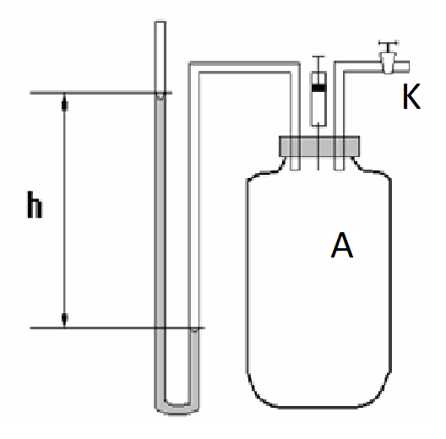
Installation for determining the Boltzmann constant (Figure 1) consists of a vessel with a capacity of 5-10 liters and connected to it water manometer. Into the vessel closing cork a tube with tap is inserted for communication with the atmosphere and the needle for introduction into a vessel of a volatile liquid. If enter into the vessel some amount of easily evaporating liquid mass of m, it will evaporate quickly and creates additional pressure P in the vessel, and the vapor pressure will be balanced out by the pressure of liquid column in manometer.
Apply to the vapors of volatile liquid Chaperon - Mendeleev equation (1).
(8)
where P- the partial vapor pressure created in the vessel by vapor of entered liquid, V - the volume of the vessel, - mass and M - molar mass of a volatile liquid, entered into the vessel. d_{liq}- density of volatile liquid, d- density of liquid used in manometer. From (8) for the Boltzmann constant obtain:
(9)
The experimental parts of work are: to determine the volume of volatile liquid taken for the experiment, to determine of difference of water level in manometer and to measure temperature in the room T (in absolute temperature scale).
The progress of work
- Open the tap K of the communication of the vessel with atmosphere for setting liquid in the manometer at same level.
- Measure the temperature T at the room.
- Close the tap K.
- Fill the syringe and enter into the vessel of volatile liquid. Syringe leave inserted into the needle in vessel cork, otherwise vessel will be communicated with atmosphere.
- After 5-10 minutes, write down the difference between the water level in the manometer.
- According to the formula (9), calculate the Boltzmann constant.
- According to the results calculate absolute and relative experimental error.

№ | d_{liq},  kg/m³ | V_{liq},  m³ | M,  kg/mol | d,  kg/m³ | V,  m³ | h, m | T,  K | k,  J/K
1.
2.
3.

Questions for laboratory work.
The basic equation of kinetic theory of gas. The ideal gas laws. The equation of state for an ideal gas (Mendeleyev - Clapeyron equation). Universal gas constant. Boltzmann's constant.
Laboratory Work # 16
Determination of resistivity according to Ohm's law.

Work Objective: Determination of specific resistance of conductor of knowing its geometric dimensions.
Accessories: Ammeter, voltmeter, rheostat, studied conductors of different diameters, micrometer, connecting wires, DC supply.

Short theoretical information

The theory.
Electric current - is orderly movement of electric charges. In metals, electrical current is created by the directional movement of free electrons and current described by the expression I = env̄A.
Here $e=1,6⋅{\text{10}}^{−\text{19}}$C the electric charge of the electron, the n - concentration, v̄- the average velocity of ordered motion of electrons, the A- cross-sectional area of the conductor.
According to the theory of Lorentz - Drude free electrons in metals behave as a monatomic gas molecule.
Calculations show that the density of electric current, which occurs under the influence of an external electric field E is determined by the expression.
$j=\frac{{\text{ne}}^{2}\bar{λ}}{2m\bar{υ}}E=σE$

where $\bar{λ}$- average free path of electrons, n - concentration of free electrons, m - its mass, $σ$- electrical conductivity of the conductor. The inverse of conductivity is called resistivity
$$ρ=\frac{1}{σ}$$
Equation is an expression of Ohm's law in differential form. $j=σE=\frac{1}{ρ}E$

Taking into account $j\text{=} \frac{I}{A}$ and $E=\frac{U}{l}$ this equation are equal: $\frac{I}{A}\text{=} \frac{U}{ρl} ⇒ I\text{=}\frac{U}{R}$
This expression is - integral form of Ohm's Law for subcircuit. Here l- the length of the conductor, U- the voltage at the ends of the conductor, R - conductor resistance, which is equal to
$R=ρ\frac{l}{S}$ (1)

Installation Description
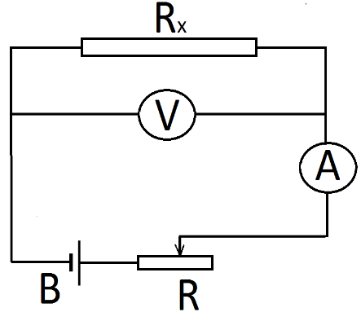
There are several methods to measure the specific resistivity. In this work, the resistance is determined on the basis of Ohm's law for subcircuit. Installation diagram is shown in Figure 1, where the resistance voltmeter should be much greater than the resistance of the tested conductor.
For current I, passing through the ammeter:
$$I\text{=}I_{x}\text{+}I_{V}\text{=}\frac{U}{R_{x}}\text{+}\frac{U}{R_{V}}$$
where $R_{x}$- the tested resistance, $R_{V}$- voltmeter's resistance. If we consider that the$R_{V}\text{>>}R_{x}$
$I\text{=}\frac{U}{R_{x}}$ and $R_{x}\text{=}\frac{U}{I}$ (2)

Knowing the length l and cross-sectional area A of the conductor, we obtain the resistivity:
$ρ\text{=}\frac{R_{x}∙A}{l}\text{=}\frac{πd^{2}∙U}{4Il}$ (3)

where A = πd²/4 and d is the cross-sectional diameter of the conductor.

Progress.

- Measure the length of the conductor and its diameter at three points.
- Assemble the circuit as shown in Figure 1.
- By changing the position of the rheostat's slider record readings of voltmeter and ammeter.
- Use equations (2) and (3) to calculate the resistance and the resistivity of conductor.
- According to the results of measurements calculate the absolute and relative uncertainties.

Data Table

№ | 1- conductor
№ | U, V | I, A | R, ohm | d, m | A, m² | ρ, ohm∙m
1
2
3
2- conductor
1
2
3

Questions for laboratory work. Electric current. Current. The current density. The electrical resistance, resistivity, conductivity. Explanation of the electrical conductivity of metals on the basis of classical electron theory.

Laboratory Work # 17
Determination of the thermal coefficient of metals resistance
Work Objective: Study of depending of metals resistance on the temperature. Experimental determination of the thermal coefficient of metals resistance.
Accessories: Thermostat, metal sample, ohmmeter, thermometer.
Short theoretical information
Electric current in metals is a directed motion of electrons. Under the influence of an external electric field, they move against the electric field lines. At the same time participating in a chaotic and directed of motion, the electrons collide with the lattice ions. Between two consecutive collisions (the mean free path equal ) electrons moving accelerated under an electric field and at the time of the collision have a kinetic energy
$$W\text{=}\frac{m{\underline{u}}^{2}}{2}$$
If we apply the laws of conservation of energy and momentum to the movement of electrons, we can see that during the collision energy given to ion, is a small fraction of the total energy of the electron.
In an inelastic collision, this ratio:
$\frac{W_{i}}{W}\text{=}\frac{m}{M\text{+}m}$,
and in elastic collision:
$\frac{W_{i}}{W}\text{=}\frac{4Mm}{(M\text{+}m)^{2}}$,
where m and M the mass of electron and ion respectively.
In both cases, this ratio is about 10⁻⁴ and the energy loss goes to the heating of the metal and as a result increasing its resistance.
Let us calculate the energy released in as heat, based on classical electron theory. Maximum speed acquired at the end of the electron free path:
$u_{max}\text{=}a\text{=}\frac{F}{m}\text{=}\frac{eE\underline{}}{m\underline{v}}$ (1)
where $\underline{v}$- mean square thermal velocity, τ - time between two collisions.
If the electron density n is the number of collisions per unit time $\underline{Z}$$W=n\bar{z}E_{k}=n\bar{z}\frac{m_{e}u^{2_{\text{max}}}}{2}=n\bar{z}\frac{m_{e}}{2}{\left(\frac{\text{eE \{}\bar{λ}}{m_{e}\bar{υ}} | \right)}^{2}$, the energy released per unit time in a unit volume of the conductor will be equal to:

$\bar{z}=\frac{\bar{υ}}{\bar{λ}}$
Taking into account that

$W=\frac{{\text{ne}}^{2}\bar{λ}}{2m\bar{υ}}E^{2}$we have (2)

The electrical conductivity of metals is
$σ=\frac{{\text{ne}}^{2}\bar{λ}}{2m\bar{υ}}$
(3)
$W={σE}^{2}=\frac{1}{ρ}E^{2}$
Thus by combining (2) and (3) we get: (4)

This is the Joule -Lents law in differential form
The high concentration (n ~ 10²⁸ m⁻³$χ=\frac{1}{3}ρ\bar{υ}\bar{λ}c_{v}$) and high mobility of free electrons in metals is the cause of their good electrical and thermal conductivity. The thermal conductivity of metals associated with the presence of free electrons, which behave as monatomic molecules. In this case, for the thermal conductivity can be borrowed the expression of the kinetic theory of gases

The specific heat capacity of a monatomic gas is
$$c_{V}\text{=}\frac{C_{V}}{M}\text{=}\frac{3R}{2M}\text{=}\frac{3k}{2m}$$
Substituting this expression in the previous we have
$χ\text{=}\frac{1}{2}nk\underline{v}\underline{}$ (5)
here k - Boltzmann constant. Combining (3) and (5) we get the Wiedemann - Franz law.
(6)
As can be seen from this formula, the ratio of the thermal conductivity to the electrical conductivity is constant for all metals and depends only on the temperature of metals. From (6) can be obtained that
$ρ\text{=}ρ_{o}\left(1\text{+}αt\right) ∨ ρ\text{=}ρ_{o}αT$ (7)
These relationships also hold true for the resistance of metals:
$R\text{=}R_{o}\left(1\text{+}αt\right) ∨ R\text{=}R_{o}αT$ (8)
where ρ_{o} and R_{o} are resistivity and resistance at temperature 0ºC respectively; α- thermal coefficient of resistance and it is equal to the relative change in the resistance of a conductor when temperature changes by 1ºC; t-temperature in degree of Celsius and T - temperature in Kelvin.

Installation Description
Installation diagram is shown in Figure 1. The tested conductor is a wire wound around a bobbin and placed in a vessel filled with industrial oil. This prevents the sample from corrosion and mechanical damage, while providing effective heat exchange. It should be borne in mind that the sample takes the temperature of the medium due to the heat transfer with finite speed, not instantaneous with some delay. Therefore, the measurement should be carried out at appropriate intervals. | 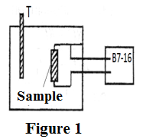

Work progress
- Using the thermostat and the measuring device B7-16 make measurements of sample resistance at every 5⁰C starting from the room temperature. According to obtained data plot the graph.  - According to the angle of graphics inclination calculate the thermal resistance coefficient α by the formula:  $$α_{φ}\text{=}\frac{tgφ}{R_{o}}$$ | 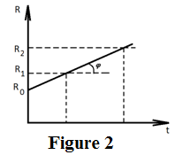
- Calculate α also by formula (8). Compare the obtained results.
- Calculate the measurement uncertainty
Data Table
№ | tº C | R_{t} Ом | tg$ϕ$ | $α$$К^{−1}$ | $α_{ϕ}$$К^{−1}$
1.
2.
3.
4.
5.
6.

Questions for laboratory work. The temperature dependence of the resistance of metals. Superconductivity.

LABORATORY № 18
DETERMINATION OF ELECTRIC CAPACITY OF THE CAPACITOR BY AC BRIDGE
Objective: Introduction to the working principle of alternating current bridge , the determination of the capacity of the capacitor by AC bridge.
Accessories: Capacitors with known and unknown capacities, slidewire, telephone, an oscilloscope, an alternator, a sound generator.
Works theory
Electrical capacitance C of a secluded conductor (conductor which is remote from the other conductors) is defined as the ratio of its charge to its potential $C=\frac{q}{ϕ}$
Electrical capacitance of the conductor increases with coming nearer of surrounding bodies to it. This is because under the influence of an electric field of a charged conductor in surrounding bodies electrical charges are induced (free in conductors and connected in insulators). This in turn leads to some reduction potential difference. In this case we can speak of mutual capacitance. Devices having mutual capacitance and capable of accumulating an electric charge are called capacitors. The electrical capacitance is determined by the formula
$C=\frac{q}{ϕ_{1}−ϕ_{2}}$
where $q$- the electrical charge of one of capacitor plates ($ϕ_{1}−ϕ_{2}$) - a potential difference between them. There are different types of capacitors: a cylindrical, spherical, flat. Capacitance depends on the geometrical shape and sizes, the dielectric constant of the material between the capacitor plates. For example the capacity of the most common parallel-plate capacitor is given by
$C=\frac{q}{ϕ_{1}−ϕ_{2}}=\frac{{\text{εε}}_{0}S}{d}$

where $ε$- the dielectric constant of the medium, $ε_{0}$ - electric constant, $S$- area of ​​one electrode, $d$- the distance between the plates.
Besides electrical capacitance, each capacitor is characterized by a maximum voltage$U_{m}$, which can be between the plates - the breakdown voltage. At voltages higher breakdown the dielectric between the electrodes breaks and the capacitor fails.
AC bridge can be used to measure the capacitance (Figure 1).
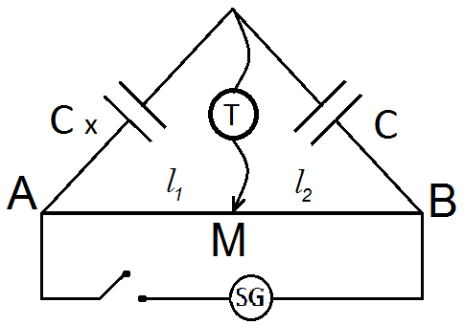
The principle of this method lies in the fact that the unknown capacitance is included in one of the arms of the bridge, then by selection of known capacitances and resistances balance of the bridge is achieved.
Conditions for balance of four arms bridge is:

$Ζ_{1}Ζ_{4}−Ζ_{2}Ζ_{3}=0$ (1)
where $Ζ_{1}$- resistance of bridge arms. Usually for four arms ac bridge two arms have an active resistance. In this case$Ζ_{1}=R_{1}$, and$Ζ_{2}=R_{2}$.
Fig. 1

To create a balance (equilibrium) to one of the arms of the bridge the reactive (capacitive) resistance $Z_{3}=R_{c}$should be connected.
Given that $R_{c}=\frac{1}{2\text{πν}c}$

where $ν$- AC frequency and using the condition (1):

$R_{1}{\text{Rc}}_{x}=R_{2}R_{c}$

$ρ\frac{l_{1}}{S}⋅\frac{1}{2π{\text{vC}}_{X}}=ρ\frac{l_{2}}{S}⋅\frac{1}{2π\text{vC}}$we can write

Hence we obtain for the unknown capacitance

$\frac{C_{x}}{C}=\frac{l_{1}}{l_{2}}$ или $C_{x}=C\frac{l_{1}}{l_{2}}$ (2)
Procedure and analysis
1. Assemble the circuit as shown in Figure 1
2. Changing the position of the slider find the point M on the slidewire, in which the sound of the phone would be minimal. Write the numerical values for this case $\text{MA}=l_{1}$ and $\text{MB}=l_{2}$ .
3. Calculate the unknown capacitance by the formula (2) (select capacitors with known capacitances ). Perform measurements for serial and parallel connections.
4. Carry out the measurements at least 3 times for different known capacitances.
5. Calculate the measurement errors.

Measurement table.

 | 1st sample |  |  |  | 2nd sample
 | $$l_{1},m$$ | $$l_{2},m$$ | $$C,F$$ | $$С_{х},F$$ | $$l_{1},m$$ | $$l_{2},m$$ | $$C,F$$ | $$С_{х},F$$
1
2
3

Questions to the lab. The electrical capacitance of a solitary conductor. Various types of capacitors, its electric capacity. Series and parallel connection of capacitors.

LABORATORY № 19
DETERMINATION OF ELECTRIC CAPACITANCE OF A CAPACITOR BY THE DISCHARGE METHOD
Objective: Study of the capacitor discharge process, the determination of capacitance of a condenser by the discharge method.
Accessories: Capacitor with an unknown capacitance, resistors with known and unknown resistances, switch, multimeter, power supply, a stopwatch.
Works theory
When the discharge of the capacitor through a permanent resistor during the time $\text{dt}$ the capacitor charge is changed by a value

$\text{dq}=−\text{Idt}$ (1)
On the other hand
$I=\frac{U}{R}$ (2)

$U=\frac{q}{C}$ (3)
Using (2) and (3) in (1) we have:
$\text{dq}=−\frac{q}{\text{CR}}\text{dt}$ (4)
where $I$- current, $U$- voltage on the capacitor $R$- resistance of resistor, С - capacitance of capacitor. A solution of equation (4) is an expression

$q=q_{0}е^{−\frac{t}{\text{RC}}}$ (5)

Deviding (5) by С :
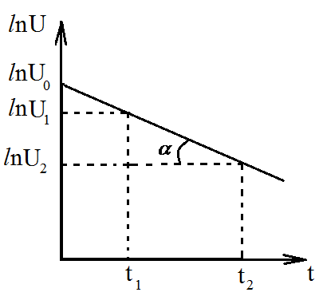
$U=U_{0}e^{−\frac{t}{\text{RC}}}$ (6)
Devide (6) by we obtain:

$I=I_{0}e^{−\frac{t}{\text{RC}}}$ (7)

Time $τ=\text{RC}$ is called relaxation time.
In practice, the graph of the logarithm of voltage versus time is more comfortable for the determination of the capacitance . Taking a logarithm of the expression (6), we obtain:
Fig. 1

$\text{ln}U=\text{ln}U_{0}−\frac{1}{\text{RC}}⋅t$ (8)

This relationship is shown on Figure 1
Now we find the tangent of the slope of a straight line:

$\text{tg}α=\frac{\text{ln}U_{1}−\text{ln}U_{2}}{t_{2}−t_{1}}$ (9)

On the other side the modulus of the tangent of the slope from the formula (8) is:
$\text{tg}α=\frac{1}{\text{RC}}$ (10)

And $C=\frac{1}{\text{Rtg}α}$ (11)

Installation diagram is shown on Figure 2. To limit the value of the current the capacitor charging process is carried out via a resistor. A digital multimeter is using to measure the current and voltage (Figure 3). You can also measure the resistance with it. The following are the meanings of symbols on the multimeter. DC - direct current, AC - alternating current,
A - current, V – voltage, Ω - resistance, m - milli, µ - micro. The numbers show the limit measurements in this mode.
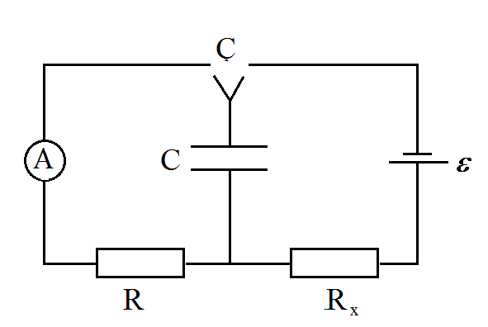
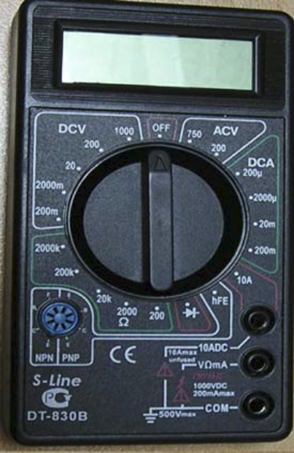

Fig. 2

Fig. 3

Procedure and analysis
1. Charge the capacitor from the source $ε$ through the resistance $R_{x}$ in 10-15 seconds.
2. Use switch Ç to discharge the capacitor through the resistance $R$, and every 5s measure its voltage.
3. Plot the graph of logarithmic dependence of voltage versus time.
4. Calculate the capacitance of the capacitor using this graph.
5. Calculate the measurement uncertainty (measured voltage is in the mode of 2000 mV, the error is 4 mV, relative error when measuring the resistance is equal to 3%).

Measurement table.

t, s
U, mV
ln U

Questions to the lab. Electrical capacitance. Various types of capacitors. Series and parallel connection of capacitors. Changing the charge and voltage on the capacitor during its charging and discharging.

LABORATORY № 21
STUDYING OF SEMICONDUCTOR RESISTANCE DEPENDING ON THE TEMPERATURE AND DETERMINATION OF THE ACTIVATION ENERGY
Objective: Study of the mechanism of electrical conductivity and resistance depending on temperature semiconductors. Determination of the activation energy.
Accessories: The semiconductor sample, thermostat, thermometer, universal voltmeter $V7−\text{16}$
Works theory
Substances by their electrical conductivity are divided into three groups:
• Metals with a resistivity ${\text{10}}^{−7}{\text{-10}}^{\text{-5}}$ ohm-meters
• Dielectrics, the resistivity of which is ${\text{10}}^{\text{12}}{\text{-10}}^{\text{17}}$ohm-meters
• semiconductors, electrical conductivity of which greater than insulators and less than that of metals. Their resistivity is in the range of ${\text{10}}^{\text{-5}}{\text{-10}}^{\text{10}}$ohm-meters
Such classification of substances is not associated with these formal features, but explained by the emergence of new energy levels - areas due to the socialization of valence electrons of interacting atoms and molecules contained in them (Figure 1).
It is known that an electric current occurs at an orderly motion of free electrons. To do this, the valence electrons from the "valence band" jumping into "conduction band" are turning to free electrons. The valence band and the conduction band are separated from each other by "forbidden zone" .
1. In metals, the valence band is partially or completely filled with electrons overlaps the conduction band (Figure 2)
2. In dielectrics, the band gap is so large (on the order of a few electron volts), that neither heat nor the energy acquired by electrons in an electric field, is not sufficient to transmit them into a free zone (conduction band Figure 3)
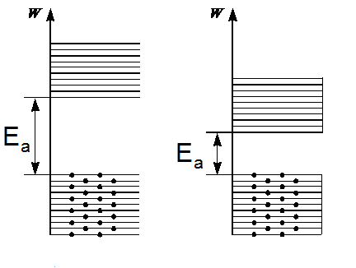
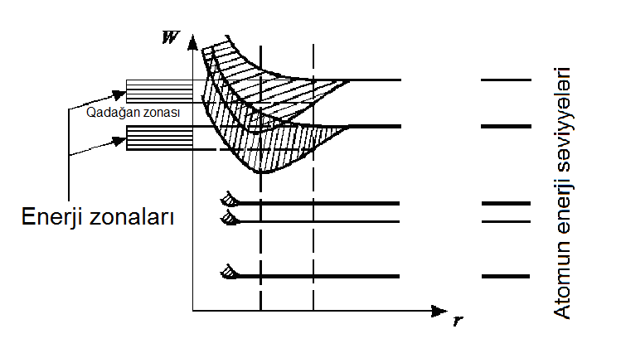

forbidden
zone
energy levels of
atom

energy zones

Fig. 1

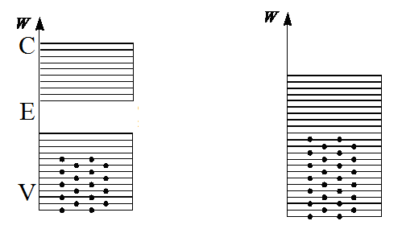
Fig. 3
conduction zone

valence zone
conduction zone

forbidden zone

valence zone
Зона проводимости

Запретная зона

Валентная зона

металлы

semiconductor
dielectric
Fig. 2

3. In semiconductors band gap smaller than that of dielectrics. In this case, the electrons under the external influence (electrical, thermal, optical, etc.) pass from the valence zone to the conduction zone. This can happen if there is vacancy in the conduction band. The energy required to transfer an electron from the valence zone to the conduction zone is called the activation energy Е_{а} .
The conductivity of the semiconductor is strongly dependent on temperature. With increasing the temperature, the valence electrons acquiring energy equal to the activation energy, are leaving the atom and become free. Due to the fact that the activation energy does not have such a greater numerical value, even at room temperature, a sufficient number of electrons can be in the conduction zone. In this case the vacancies formed in the valence band, behave as positive charges and are called the holes.
The holes, moving opposite with respect to the electrons involved in the creation of the current in a semiconductor. Thus the own conductivity of semiconductors consists of electron and hole conduction.

$σ=\text{en}μ_{n}+\text{ep}μ_{p}$ (1)
Here, n and p, respectively, the concentration of electrons and holes, $μ_{n}$and $μ_{p}$their mobilities.
Mobility is numerically equal to the velocity acquired by the charge carriers in the electric field of unit strength.
$μ=\frac{ϑ}{Е}$
In semiconductors, the conduction band electron concentration obeys the exponential law
$n=n_{0}e^{−^{\frac{E_{a}}{2\text{kT}}}}$ (2)
where $n_{0}$- coefficient of proportionality, weakly temperature-dependent, $Е_{а}$- activation energy – the energy equal to the band gap. The energy required to create a free charge carrier is $\frac{Е_{а}}{2}$ (two carriers - electron - hole pair, are formed at an energy expenditure of Е_{а}). Therefore, the temperature dependence of the own conduction is:

$σ=σ_{0}е^{−\frac{Е_{а}}{\text{2KT}}}$ (3)

The temperature dependence of the resistance of conductors can be written as:

$R=R_{0}e^{\frac{E_{a}}{2\text{KT}}}$ (4)

Taking the logarithm of expression (4), we obtain:

$\text{ln}R=\text{ln}R_{0}+\frac{E_{a}}{2\text{KT}}$ (5)

In practice it is convenient to calculate the activation energy from the relation:
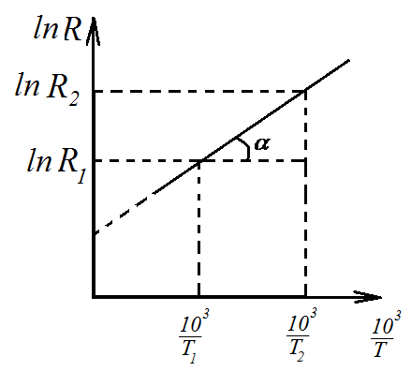
$\text{ln}R=f\left({\frac{\text{10}}{T}}^{3}\right)$ (6)
Figure 4. shows a graph of this relationship.

For the tangent of the slope angle direct obtain:
$\text{tg}α=\frac{\text{ln}R_{2}−\text{ln}R_{1}}{\frac{{\text{10}}^{3}}{T_{2}}−\frac{{\text{10}}^{3}}{T_{1}}}=\frac{\text{ln}\frac{R_{2}}{R_{1}}}{\frac{{\text{10}}^{3}}{T_{2}}−\frac{{\text{10}}^{3}}{T_{1}}}$ (7)
Using the expression (5), to obtain a tangent:
Fig. 4
$\text{tg}α=\frac{E_{a}}{2K}⋅{\text{10}}^{−3}$ (8)
Given this expression, we can calculate the numerical value of the activation energy $E_{a}=2K⋅{\text{10}}^{3}\text{tg}α$ or $E_{a}=0,\text{17}\text{tg}α$ (eV)
Thus, determination of the activation energy is reduced to the determination of the angle coefficient from the plot of resistance versus temperature. The device scheme for determining the activation energy is shown in Figure 5.
Thermometer Thermostat
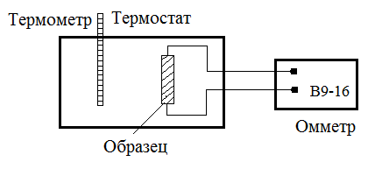
Sample Ohmmeter
Fig. 5

Procedure and analysis
1. Measure the resistance of a semiconductor placed in an thermostat using an ohmmeter at room temperature. By turning on a thermostat measure the sample resistance every 100C, recording them in the table.
2. Performing 8-10 measurements, and draw the graph on the received data ,and calculate the tanget of slope angle using the formula 7.
3. Use the result obtained to calculate the activation energy according to the formula 9 .
4. Calculate the absolute and relative measurement error.

Measurement table.

$$r_{n},M$$
$$R,\text{Om}$$
$${{\text{10}}^{3}}/T$$
LnR

Questions to the lab. Zone theory of solids. Semiconductors. Semiconductors of n and p types. Own and impurity conductivity.

LABORATORY № 22
DETERMINATION OF THE HORIZONTAL COMPONENT OF THE EARTH'S MAGNETIC INTENSITY
Objective: Acquaintance with elements of terrestrial magnetism, determination of the horizontal component of the earth's magnetic field strength.
Accessories: Tangent - galvanometer, constant current source, ammeter, rheostat.
Works theory
The earth is a huge ball magnet whose poles lie near geographic poles: near the northern geographic pole is located the southern magnetic S, and near the southern geographic pole - the northern magnetic pole N (Fig. 1). At any point on the surface of the earth and in the surrounding space, the effect of the magnetic field is detected. The direction of the Earth's magnetic field lines can be set with a magnetic needle. At the equator, the magnetic field is directed horizontally, and at the magnetic poles it is vertical, at other points it is directed at some angle to the earth's surface. This angle is called the declination angle and is denoted by a letter $ϕ$.
The projection of magnetic field induction onto the horizontal plane is called the horizontal component of the Earth's magnetic field (B). The direction of this component is taken as the direction of the magnetic meridian. The vertical plane passing through such a meridian is called the plane of the magnetic meridian. The angle between the geographic and magnetic meridians is called magnetic declination ($ϕ$).
Lines of the Earth's magnetic field, generally speaking, are not parallel to the Earth's surface (Fig. 1). This means that the magnetic induction of the Earth's field does not lie in the plane of the horizon of the given place, but forms an angle with this plane. This angle is called the magnetic inclination and is denoted by a letter$β$. Earth magnetism is characterized mainly by three quantities: the horizontal component$B_{\text{11}}$, the angle of declination $ϕ$and the angle of inclination$β$.
Knowing the angle of declination and the magnitude of the horizontal component of the magnetic field strength of the Earth in some place, it is possible to determine the magnitude and direction of the vector of magnetic induction corresponding to that place.
In this paper, the horizontal component of the Earth's magnetic field intensity $H_{\text{11}}$is calculated. For this, a connection is used between the vector of magnetic induction and the intensity of the earth's magnetic field.
$\overset{}{\overset{→}{B}={\text{μμ}}_{0}\overset{→}{H}}$
where $μ_{0}=4π⋅{\text{10}}^{−7}{\text{Hn}}/m$ the magnetic constant, $μ$ is the magnetic permeability of the medium.
To determine the horizontal component of the induction of the Earth's magnetic field, the tangent-galvanometer (TG) is used (Fig. 2). The TG is a coil of radius R with a certain number of turns of wire n located in the vertical plane. A compass is placed in the horizontal plane at the center of the coil, the arrow of which can rotate about the vertical axis under the influence of the horizontal component of the induction of the Earth's magnetic field. In the absence of current in the coil, the magnetic needle is directed along the magnetic meridian of the Earth MM (Fig. 3). Aligning the plane of the coil with the plane of the magnetic meridian can be achieved by turning the plane of the turns around the vertical axis. If after that to pass current through the turns, then the magnetic needle will turn to some angle $ϕ$ (Fig. 3). This is explained by the fact that along with the magnetic field of the Earth$B_{\text{11}}$, a magnetic field is created by a field $B_{0}$created by a circular current in the center of the turns. According to the Bio-Sawar-Laplace law, the magnetic induction at the center of the circular current is calculated by the formula:
$B_{0}=\frac{μ_{0}μJ⋅n}{2R}$ (1)
On the other hand, as seen from (Fig. 3).
$\text{tg}ϕ=\frac{B_{0}}{B_{\text{11}}}⇒B_{\text{11}}=\frac{B_{0}}{\text{tg}ϕ}$ (2)
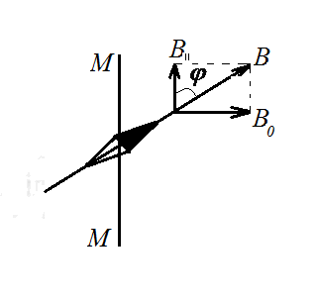
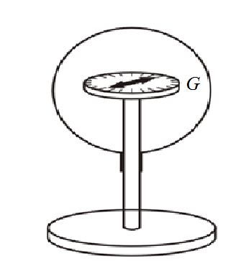
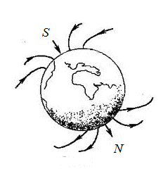

Fig.1
Fig.3
Fig.2

Substituting (1) into (2) we obtain
$B_{\text{11}}=\frac{μ_{0}μJ⋅п}{2\text{Rtg}ϕ}$ (3)
If we take into account that$μ=1$, then for the horizontal component of the magnetic field intensity of the Earth we have:
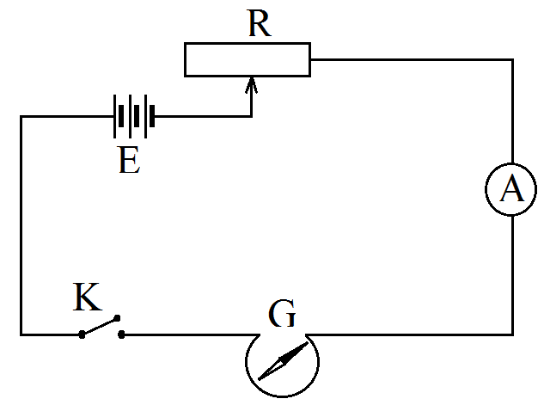
$H_{\text{11}}=\frac{J⋅n}{2\text{Rtg}ϕ}$ (4)
The scheme of the experimental setup is shown in Fig.4. Here E is the power source, R is the rheostat, A is the ammeter, K is the key, and G is the tangent is the galvanometer.

Fig. 4

Procedure and analysis
1. Arrange the plane of the turns in the plane of the magnetic meridian. In this case the magnetic needle is located in the plane of the turns.
2. By closing the key, increase the current through the turns until the magnetic needle turns by 30 to 60⁰ (better results are obtained at angles close to 45⁰)
3. Knowing the radius R and the number of turns n, (usually these values are indicated by the TG), calculate the numerical value by the formula 4.
4. Repeat the experiment at different values of the current. Calculate the absolute and relative errors of the experiment.

Measurement table.

№ | $$J$$ | $$ϕ$$ | п | $$R$$ | $$H_{\text{11}}$$
1
2
3
4

Questions to the lab. Magnetic field of a conductor with a current. Intensity and induction of the magnetic field. The Bio-Savar-Laplace law. The intensity of the magnetic field in the center and on the axis of the circular current.

Laboratory Work # 23
Determination of the specific charge of an electron by magnetron

Work Objective: Introduction to one of the methods of studying of charged particles motion in electric and magnetic fields, and determination of specific charge of an electron.
Accessories: Electronic lamp 204 S, three DC sources: 100-150 V for anode circuit, 20-30 V for solenoid and 1-2 V for cathode circuit, microammeter of DC current and connecting wires.
Short theoretical information

The main characteristics of the charged particle are its charge and mass. The trajectory of a charged particle in electric and magnetic fields determined by the characteristics of these fields and the specific charge of the particle. The specific charge of the particles is the ratio of the charge q of the particle to its mass m (q / m). The specific charge of the SI is measured in C / kg. Having empirically determined specific charge of the particles, and knowing the amount of its charge, the mass of the particle can be calculated with high accuracy. It should be noted that the determination of the specific charge of the unknown particles at one time led to the discovery of the electron.
One method of determining the specific charge of an electron is the method of magnetron. The essence of this method is as follows: is known that moving in a magnetic field charged particle experiences Lorentz force, which is determined by the formula

$$\vec{F}\text{=}q∙\vec{v}×\vec{B}$$

where - q charge of the particle, v - its velocity, B - magnetic induction. The direction of the Lorentz force is determined according to the "right hand" rule (Figure 1)
The force acting on a negative charge, is in the opposite direction. In case where v and B are parallel, the Lorentz force is zero. And if they are mutually perpendicular, in a uniform magnetic field, an electron will move in a circular path. According to the Newton's second law F = ma. Considering that the a =v²/R we get  $evB\text{=}\frac{mv^{2}}{R}$ and $\frac{e}{m}\text{=}\frac{v}{BR}$ (1)  where - electric charge and m - mass of the electron. | 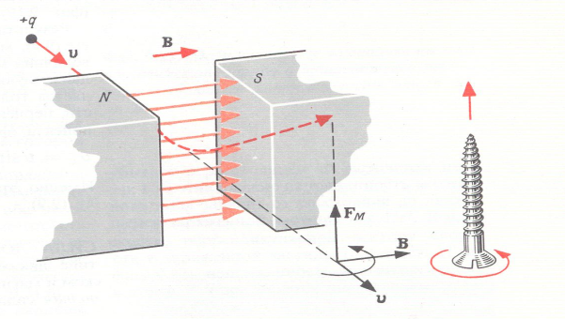  Figure 1
On practice this condition can be realized in a vacuum tube with a cathode filament and being coaxial with it metal cylinder, which is the anode. The lamp is placed inside the solenoid, which magnetic field is directed along the axis of the anode (Figure 2). Here, A - anode, K - cathode. The nature of the electron motion inside the lamp depends on the magnetic field induction of solenoid. Figure 3 shows the possible options trajectories. In the absence of a magnetic field (B = 0) the electrons emitted from the heated cathode moving in the radial direction under the influence of an electric field, reach the anode, thereby creating a current in the anode circuit. In the event of existing of magnetic field as well as electric field, Lorentz force acts on the electrons, and they are moving along a trajectory close to circular. With increasing magnetic induction circular orbit radius decreases. |  | 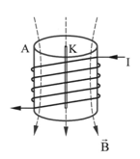  Figure 2
At a certain value of the magnetic field of the solenoid (this value is called the critical B = B crit) the circular trajectory of the electrons only touches the anode and the current stops. If comes the moment when B> B crit, the electrons can't reach anode. In the lamp with a very thin cathode, the radius of the electron trajectory is equal to the half of anode radius when the conditions of B = B_{crit} is satisfied. Electron moving between the cathode and anode being accelerated by electric field acquires kinetic energy.
$eU_{A}\text{=}\frac{mv^{2}}{2}$ (2)
where U_{A} - is a anode voltage. Considering that R= r_{A}/2 from (1) and (2) for specific charge we have:  $\frac{e}{m}\text{=}\frac{8U_{A}}{(B_{crit}∙r_{A})^{2}}$ (3)  Critical magnetic induction of solenoid is determined by the expression  B_{crit} = μ∙μ_{o}∙n∙J_{crit}  where μ_{o} = 4π∙10⁻⁷ Hn/m - magnetic constant, μ - magnetic permeability of air, J_{crit} - the current in the solenoid, n = N/l - number of coils of solenoid per unit length. Taking this into account, for the specific electron charge we get: | 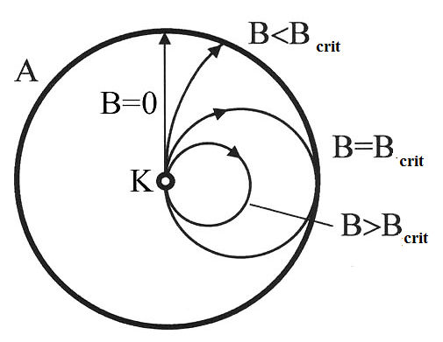  Figure 3
$\frac{e}{m}\text{=}\frac{8U_{A}}{(μ_{o}n∙r_{A}∙J_{crit})^{2}}$ (4)

Description of Installation

The experimental setup is shown in Figure 4. If all the electrons move at the same speed, the dependence of the anode current on the magnetic induction would be expressed by the dashed line (Figure 5a). The real relationship J_{A} = f(B) is shown in the same figure, as a solid line. Thus the numerical value of anode current J_{crit} is defined as the middle point of the segment cd of the depending of anode current J_{A} on the current in the solenoid J_{s} (in Figure 5b). | 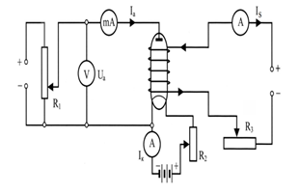  Figure 4

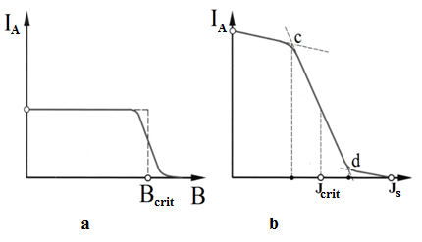
Figure 5

The work progress

- Set a certain value of the anode voltage U_{A}.
- Turn on solenoid circuit and set current in the circuit to a minimum value.
- Increase the amperage in the solenoid, measure the corresponding values of anode current and record they in the table. This requires to make 10-12 measurements at different solenoid currents.
- On the basis of obtained data plot a graph of the anode current vs. of the current in the solenoid J_{A} = f (J_{s}).
- Continue straight cd section of graph to its intersection with the abscissa axis (Figure 5). Drop a perpendicular from the midpoint of cd section to abscissa axis. The point of intersection of the perpendicular corresponds to the value of J_{crit}.
- Calculate the values of $\frac{e}{m}$ by formula (4) for three different anode voltages.
- Define average value of $\frac{e}{m}$

Table 1

 | U_{A1} = V |  | U_{A2} = V |  | U_{A3} = V
 | J_{s}, A | J_{A}, mA | J_{s}, A | J_{A}, mA | J_{s}, A | J_{A}, mA

Table 2
 | U_{A}, V | J_{crit}, A | $\frac{e}{m}$ , C/kg | Average $\frac{e}{m}$ , C/kg
1
2
3

Questions for laboratory work.
Ampere force and Lorentz force. The magnetic field of the solenoid. The motion of a charged particle in a magnetic field.

LABORATORY № 24
DETERMINATION OF THE COEFFICIENT OF SELF – INDUCTION BY JOUBERT METHOD
Objective: Introduction to one of the methods for determining the inductance and study the influence of ferromagnetic core to inductance of coil .
Accessories: The study coil, iron core, voltmeter and ampermeter AC, power supply.
Works theory
Occurrence of electromotive force (emf) in a conductor, due to the change of current flowing through it is called self-induction . It was established experimentally that the emf occurring in a circuit is directly proportional to the rate of change of current
$ε_{i}=−L\frac{ΔJ}{Δt}$
On the other hand, according to Faraday's law of electro-magnetic induction, arose emf which determined by the rate of change of the magnetic flux Ф:
$ε_{i}=−\frac{ΔФ}{Δt}$
According to the Biot-Savart-Laplace law the value of magnetic induction is proportional to the current, that generates a magnetic field.
The magnetic flux and the current flowing through the loop, related by:
$Ф=\text{LJ}$ (1)
where the coefficient of proportionality $L$ is called inductance. This relationship between the magnetic flux and the electric current is true if the magnetic permeability of the medium ($μ$) does not depend on the magnetic field intensity (H). It should be noted that the magnetic flux Ф is also changed according to the shape and geometrical dimensions of the loop. This change is due to dependence of inductance on the geometric dimensions of loop and of the magnetic permeability of the medium. When current flows through the long enough solenoid the arising magnetic field can be considered uniform and the magnetic induction coil in this case is expressed as:
$$Β=μ_{0}μ\text{nJ}$$
Then the magnetic flux through the coil is equal to
$Ф={nФ}_{0}=\text{nlBS}=μ_{0}μ⋅n^{2}\text{lSJ}$ (2)
where $l$- the length of the solenoid, $S$- cross-sectional area, $μ_{0}=4π⋅{\text{10}}^{−\text{17}}$H / m - magnetic constant, n - the number of turns per unit length of the solenoid.
Comparing the expressions (1) and (2) for inductance of a solenoid we obtain
$L=μ_{0}{μn}^{2}\text{lS}=μ_{0}{μn}^{2}V$ (3)
If there is not core inside solenoid , the
$L=μ_{0}n^{2}\text{lS}=μ_{0}n^{2}V$ (4)
where $V=\text{lS}$- the volume of the solenoid. From (3) and (4)
$L={μL}_{0}$ and $μ=L/{L_{0}}$ (5)
The inductance can be determined more than by one way. One of these methods is the method of Joubert. The essence of this method is as follows: R coil resistance in the DC circuit, regardless of its shape, depends on the length, cross-sectional area and the conductor material. This is called the ohmic resistance of the conductor or active resistance. If the conductor is fed by AC voltage
$U=U_{m}\text{cos}2\text{πν}t$ (6)
the alternating current flows in it
$i=\frac{U}{R}=\frac{U_{m}}{R}\text{cos}2\text{πν}t=J_{m}\text{cos}2\text{πν}t$ (7)
where $U_{m}$- the voltage amplitude, $ν$- the frequency of its changes. If in circuit in addition to the active resistance there is also an inductance$L$, the current in the circuit depending on the time varies as:
$i=J_{m}\text{cos}(2\text{πν} t−ϕ)$ (8)
where $J_{m}$- the peak value of the current is determined from the expression:
$J_{m}=\frac{U_{m}}{\sqrt{R^{2}+4π^{2}ν^{2}L^{2}}}$ (9)
$ϕ$- the phase difference between voltage and current strength.
$\text{tg}ϕ=\frac{2\text{πν}t}{R}$ or $\text{cos}ϕ=\frac{R_{L}}{Z}$ (10)
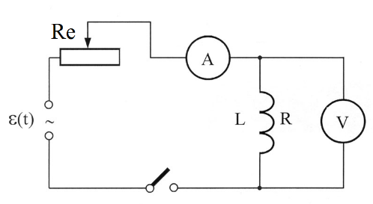
From a comparison of (6) and (8) we see that the current lags the voltage by phase. Expression $Z=\sqrt{R^{2}+4π^{2}ν^{2}L^{2}}$ from the formula (9) is called impedance and $R_{L}=2\text{πν}L$ is called inductive resistance. In formula (6) and (7) we have the amplitude values ​​of current $J_{m}$and voltage$U_{m}$. But measuring devices measure the current values (effective) ​​of these
Fig. 1
quantities $J_{g}$and $U_{g}$. The connection between them is determined
$A_{c}$ by the ratio:
$J_{m}=J_{g}\sqrt{2}$ and $U_{m}=U_{g}\sqrt{2}$
Considering this in equation (9) we obtain:
$J_{g}=\frac{U_{g}}{Z}$ or $J_{g}=\frac{U_{g}}{\sqrt{R^{2}+4π^{2}ν^{2}L^{2}}}$ (11)
Let us find out the inductance (9)
$L=\frac{1}{2\text{πν}}\sqrt{Z^{2}−R^{2}}$ (12)
where $Z=\frac{U_{g}}{J_{g}}$ (13)
the impedance of solenoid. According to formula (12) by known $Z,R$ and $ν$the inductance can be calculated. To do this, use the scheme shown in Figure 1. here $R_{e}$- a rheostat, $A_{c}$- key, $L$- the coil with resistance$R$, A- ammeter, $V$ - voltmeter.

Procedure and analysis
1. Remove the core from the coil and use the key to complete the circuit.
2. By changing the position of the slider rheostat, measure 5 different values of current $J_{g}$and voltage$U_{g}$.
3. Repeat these measurements after entering core into the coil .
4. Using the formulas (13) and (12) calculate the impedance and inductance of the solenoid for the two cases.
5. Using the values of inductance of the solenoid with core (4) and without $\left(L_{0}\right)$ it, using the formula (5) calculate the permeability $(μ)$.
6. Calculate the relative measurement error.

Measurement table.

Without core | $$J_{g},A$$ | $$U_{g},V$$ | $$Z,\text{Ohm}$$ | $$L_{0}\text{Hn}$$
1
2
3

With core | $$J_{g},A$$ | $$U_{g},V$$ | $$Z,\text{Ohm}$$ | $$L_{0}\text{Hn}$$
1
2
3

Questions to the lab. The phenomenon of electro-magnetic induction. Self-inductance. Extra current after closing and opening the circuit. The magnetic field strength inside and outside the solenoid. The inductance of the coil. Alternating current.

LABORATORY № 25
STUDY OF THE HALL EFFECT
Objective: To study the Hall effect and the determination of the concentration of charge carriers in semiconductors.
Accessories: The sample of crystalline silicon, permanent magnet, DC source, a microammeter, milliammeter.
Works theory
American scientist Hall in 1880, based on conducted experiments discovered the following phenomenon: if the metal plate along which flows a constant electric current, placed perpendicular to the magnetic field, between faces parallel to the current and the field a potential difference is produced. Its value is given by
$Δϕ=ϕ_{A}−ϕ_{c}=R\frac{\text{JB}}{b}$ (1)
where J - current, B - magnetic field, b - width of the plate in the direction of the magnetic field, R - different for different metals, the coefficient of proportionality, known as the Hall constant. The phenomenon is called the Hall effect.
Hall phenomenon is observed not only in metals but also in semiconductors, and from the sign of the effect can be determined belonging of semiconductor to the n - and p -type.

The Hall effect is very simple explained by the electronic theory. Let us assume that the concentration of conduction electrons in a conductor is equal to n, and the average velocity of ordered motion -$ϑ$. Then, the current in the conductor is equal to:
$J=\text{jS}=\text{en}ϑ\text{aв}$ (2)

When the magnetic field perpendicular to the current, the Lorentz force acting on the moving electrons, changing the trajectory, forward them to the upper face of the plate 1 (Figure 1). As a result, between the surfaces 1 and 2 there is a transverse electric field. The force $\overset{→}{F}=e\overset{→}{E}$ acting on the electron in this field is directed against the Lorentz force. In the case of dynamic equilibrium:
$e\overset{→}{E}+e\left[\overset{→}{ϑ}×\overset{→}{Β}\right]=0$

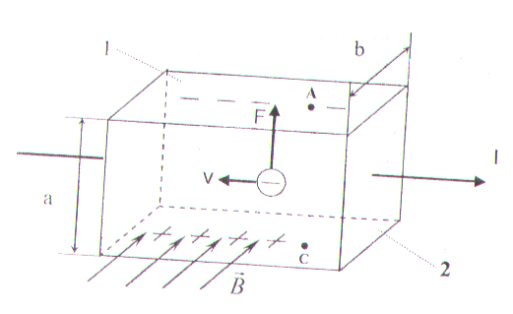
Fig. 1

And from here$\overset{→}{E}=−\left[\overset{→}{ϑ}×\overset{→}{Β}\right]$. As can be seen from the figure, the potential difference between points A and C is equal to
$Δϕ=ϕ_{A}−ϕ_{c}=E⋅a=ϑ\text{Ba}$ (3)
Taking into account (2) (3), we can write that
$Δϕ=ϕ_{A}−ϕ_{c}=\frac{\text{JB}}{\text{enb}}$ (4)
From a comparison of the formulas (4) and (1) must be:
$R=\frac{1}{\text{en}}$ (5)
Thus, by calculating the Hall coefficient, it is possible to determine the nature and concentration of charge carriers. If we take into account the thermal electron velocity distribution, for the Hall constant a more accurate expression is obtained:
$R=3π/8\text{en}$ (6)
from which for electron concentration:
$n=\frac{3π}{8\text{eR}}$ (7)

To study the Hall effect using an experimental equipment, shown in Figure 2. Where 1 - power supply 2- millivoltmeter, 3 - test sample, 4 - permanent magnet, 5 - milliamp.

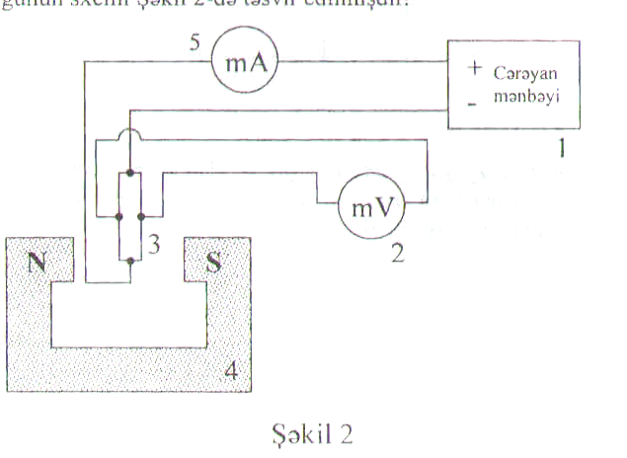
+ DC
- source питания
Fig. 2

Procedure and analysis
1. Giving high voltage in the range of 1 - 3 V from the DC source to the sample , note the corresponding values of current and potential difference.
2. Use the known geometric dimensions of the sample and the magnetic field to calculate the concentration of electrons by the formula (7) .
3. Calculate the relative and absolute measurement error.

Measurement table.

№ | $$J,\text{mA}$$ | $$Δϕ,\text{mV}$$ | $$n,m^{−3}$$
1
2
3

Questions to the lab. Explanation of the Hall effect according to electronic theory. Features of the Hall effect in metals and semiconductors. The mobility of the charge carriers.

LABORATORY № 26
THE STUDY OF THE MAGNETIC PROPERTIES OF FERROMAGNETICS
Objective: Experimental study of the magnetic properties of ferromagnet materials in an alternating magnetic field and learning the skills of the research process of magnetization of ferromagnetic materials with an oscilloscope.
Accessories: Sound Generator, two channel of oscilloscope, the sample (toroid), capacitors and resistors.
Works theory
Ferromagnetics are the substances with high magnetic permeability. These include $\text{Fe},\text{Ni},\text{Co},\text{Cd}$and their alloys with other metals. Ferromagnetic materials have a number of features that distinguish them from other magnets. They tend to the phenomenon of hysteresis.
It consists in that the magnetic induction B in the ferromagnetic depends not only on the value of the magnetizing field strength H at the moment, but also on how it was changing in the previous time points. Therefore, the induction B is not a single-valued function
The concept of differential permeability $μ$ is introduced for ferromagnets.
$μ=\frac{1}{μ_{0}}\frac{\text{dB}}{\text{dH}}$ (1)
If a ferromagnet placed in a magnetic field, which intensity gradually increases the magnetization can be brought to saturation, and the dependence of B on H (magnetization curve) will be expressed by portion OA (Figure 1). By reducing to zero of magnetizing field the magnetization curve does not follow the original curve AO, but follows the AC curve. As a result,
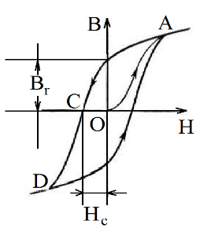
when removing the external magnetic field, ferromagnetic material is magnetized with a residual induction$B_{г}$. It is necessary to make the magnetic field with the reverse direction and the value H_{с} for a complete demagnetization of the sample. H_{с} is called the coercive force. Thus, with an increase of H, the ferromagnetic material is completely demagnetized at the point "C". With a further increase of the magnetic field the ferromagnet is magnetized again, reaching a saturation point D. As can be seen from figure 1, at a variable change in the direction of the magnetizing field the dependence of the B from H is represented by a
closed curve, which has the name of the hysteresis loop.
Fig. 1
Nature of ferromagnetism was revealed by quantum mechanics. Under certain conditions, in some crystals can occur so-called exchange forces that cause the magnetic moments of the electrons to line up parallel to each other. As the result there are regions of spontaneous (spontaneous) magnetization, which are also called domains (fig.2a.). domains have dimensions of the order of 10⁻⁴-10⁻³ sm. Within each domain ferromagnet spontaneously magnetized to saturation and has a certain magnetic moment. The directions of these moments are different for different domains (Fig.2b), so that in the absence of an external field the total moment of the whole body is zero. Effects of magnetic field on the ferromagnetic leads to a rotation of the magnetic moments of the domains in the field direction (fig.2c).
The dependence of the directions of the magnetic moments of domains from the external magnetic field direction leads to the formation of the hysteresis loop. When performing one cycle of reversal magnetization of ferromagnet the work is numerically equal to the area of ​​the hysteresis loop. This work goes into heating the ferromagnet.
$W=\int{\text{BdH}}$ (2)
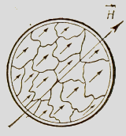

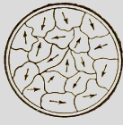

Fig.2а
Fig.2c
Fig.2b

Hysteresis loop can be observed on an oscilloscope screen (Figure 3).
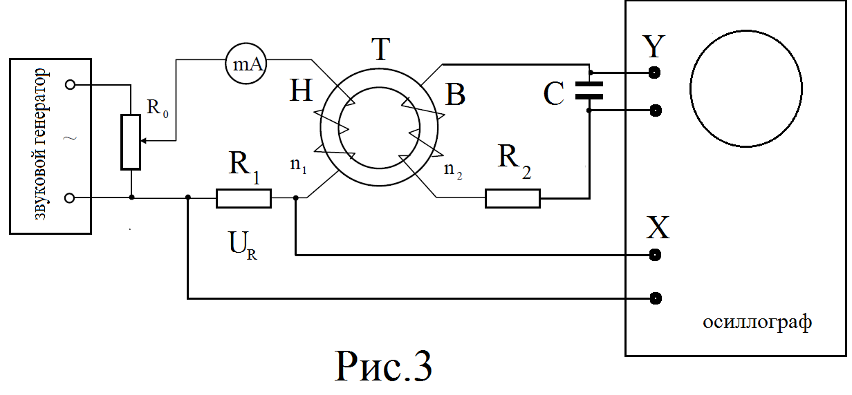
oscilloscope
Sound Generator
Fig. 3

The test sample is made in a toroidal shape, on the surface of which two coils are uniformly wound with the numbers of turns per unit of length $n_{1}$ and $n_{2}$. The first coil through the resistor with resistance $R_{1}$ is connected to the output of the sound generator with an output voltage of sinusoidal waveform.
The magnetic fields in the toroid is defined by the formula:
$H=n_{1}J_{1}$ (3)
where $J_{1}$ - the current in the primary coil. The voltage drop in the resistor$R_{1}$.
$U_{1}=J_{1}R_{1}$ (4)
From (3) and (4) we get:
$H={\text{kU}}_{1}$ (5)
Where $k=\frac{n_{1}}{R_{1}}$.
Since an alternating voltage is applied in the coil , according to the formula (3), the magnetic field will change with the frequency of alternating current in a range from -$H$ to +$H$. In the secondary coil emf induction
$ε_{1}=−N_{2}\frac{dФ}{\text{dl}}=−N_{2}S\frac{\text{dB}}{\text{dt}}$ (6)
Here, $N_{2}$- the number of turns in the secondary coil, $Ф=\text{ВS}$- the flux of the magnetic field through the cross section of the toroid. According to Ohm's law, for the secondary coil:
$ε=J_{2}R_{2}+U_{c}$
where $J_{2}$- the current in the secondary coil, $U_{c}$- the voltage across the capacitor. If $R_{2}$ and $C$- capacitance so large that $J_{2}R_{2}\text{>>}U_{c}$

$J_{2}=\frac{ε_{i}}{R_{2}}=\frac{N_{2}\text{SdB}}{R_{2}\text{dt}}$ ( 7)
In this case, the capacitor voltage
$U_{c}=\frac{q}{C}=\frac{\int{J_{2}}\text{dt}}{C}=\frac{N_{2}S}{R_{2}C}\int{ \frac{{\text{dB}}_{2}}{\text{dt}}\text{dt}=\frac{N_{2}{\text{SB}}_{2}}{R_{2}C}}$ (8)

Introducing the notation $\frac{R_{2}C}{N_{2}S}=K_{2}$

obtain $B_{2}=K_{2}U_{C}$ (9)
As seen from expressions (5) and (9), a voltage $U_{1}$ is proportional to the magnetizing field strength, and $U_{c}$- magnetic induction in the sample. If the voltage $U_{1}$is applied to the horizontal deflection plates of the oscilloscope, the electron beam in the X-axis will deviate proportional to H, and in the Y-axis direction proportional to the induction B. For a full cycle of changes of the external field H, an electron beam of oscilloscope follows a closed hysteresis loop. By varying the voltage across the primary winding obtain different sizes of loops. The top of each loop is a point which corresponds to the saturation maximum of the basic magnetization curve. Voltages $U_{1}$ and $U_{C}$ can be determined by knowing the voltages $U_{x}$ and $U_{y}$causing the deviation of electron beam by one division in the X and Y axes:
$U_{1}=n_{x}U_{x}$ and $U_{C}=n_{y}U_{y}$
where $n_{x}$ and $n_{y}$ - the coordinates of the vertices of the hysteresis loop.
Substituting the last expression in the formula (5) and (9) we get:

$H={\text{kU}}_{1}={\text{Kn}}_{x}U_{x}=к_{x}n_{x}$
$B=K_{2}U_{y}n_{y}=K_{y}n_{y}$ (10)
where
$K_{x}={\text{KU}}_{x}=\frac{n_{1}U_{x}}{R_{1}}$ и $K_{y}=K_{2}U_{y}=\frac{R_{2}C}{N_{2}S}U_{y}$ (11)

Procedure and analysis
1. Connect the generator and oscilloscope to the power supply.
2. Project an electron beam to the center of the grid on the oscilloscope screen.
3. At a maximum output voltage of the generator, using handles "reinforce in vertical" and "reinforce in horizontal" of an oscilloscope get the maximal possible hysteresis loop on the oscilloscope screen.
4. By reducing the output voltage of the generator, get some of the hysteresis loops. Note for each of them the coordinates of the vertices $n_{x}$and $n_{y}$.
5. According to the formula (11) calculate $K_{x}$and $K_{y}$.
6. Calculate the value $H=K_{x}n_{x}$ and $B=K_{y}n_{y}$for the vertex coordinates of all received loops.
7. According to the obtained data draw the graph of dependence $B=f\left(H\right)$.
8. Using the graph $B=f(H)$, draw the graph of dependence $μ=f(H)$.

Measurement table

№ | $$n_{x}$$ | $$n_{y}$$ | $$K_{x}$$ | $$K_{y}$$ | $$H$$ | $$B$$ | $$\text{ED}=d_{\text{sin}}ϕ=\text{IK}λ$$
1
2
3

Questions to the lab. The magnetic field in the medium. Magnetics. Ferromagnetism. Hysteresis. The phenomenon of electromagnetic induction. Lenz's rule.

Laboratory Work # 27
Determination of the refractive index of liquids by refractometer
Work Objective: The study of the work principle of the refractometer and determination of a refractive index of various liquids.
Accessories: refractometer IRF-22, investigated liquids, dropper, cotton.

Short theoretical information

In this work we define the index of refraction of transparent liquids. The refractive index of the substances can be determined in various ways. The method we use is based on the law of total internal reflection.
As it is known, when a ray of light transits from an optically denser medium to a less dense medium, refracted and deviates from the normal (Figure 1 a). It is obvious that with increasing the incident angle, the intensity of the refracted beam decreases and the reflection intensity increases. At a certain value of the incident angle i_{o}, the refracted ray glides over the interface of two media (Fig.1b). In this case, the refractive angle is 90º and the angle i_{o} of incidence is called the limit angle. If the angle of incidence is greater this angle, the light ray not passing into the second medium, undergoes total internal reflection (Fig. 1c).
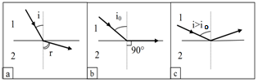
Figure 1.

According to the law of refraction
$\frac{sinsin i_{o} }{sinsin {90}^{o} }\text{=}\frac{n_{2}}{n_{1}}$ and $sinsin i_{o} \text{=}\frac{n_{2}}{n_{1}}$
For precise and rapid determination of the refractive index of the medium are used a special optical device - refractometer. There are different types of refractometers. In this study used the refractometer IRF-22 (Abbe type refractometer.)
Installation Description
The refractometer IRF-22 determines the refractive index of liquids within range from 1.33 to 1.72. It consists of two rectangular prisms and telescope (Figure 2).

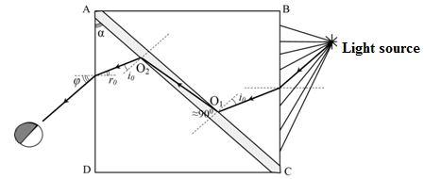
Figure 2.
The telescope consists of lenses. In the common focal plane of the lens is located cross, formed by thin filaments. Telescope is strongly fixed, but holder with prisms can rotate. With holder bonded pointer, which can move over the limb. Limb calibrated directly in the values of the refractive index.
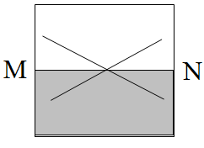
The prisms are made of high quality glass whose refractive index is 1.72. Rays' passing in these prisms is shown in Figure 2. The beam reflected from the mirror surface is directed to the BC side surface of ABC prism and after refraction it falls on the matted surface AC. Scattered at different angles (from 0º to 90º) from the surface AC light beams then pass through the liquid layer, located between the faces of the prism.
Figure.3
When the angle i of the incidence ray is i<i_{o}, the refracted light can passing through the liquid, falls on the ACD prism and illuminates it. The rays with angles of incidence i>i_{o} can't penetrate and illuminate ACD prism as a result of total internal reflection. Therefore, the AD side face of the ACD prism is divided into two parts - the illuminated and dark. Between them there is a sharp boundary, determined by the fall angle i=i_{o} (Figure 3).
MN boundary position depends on the limiting angle i_{o}, which in turn depends on the refractive index of the liquid sample. Therefore, it is possible to calibrate the scale of device, so that according a certain position of the border we directly determine the refractive index of liquid.

Work progress
- Slightly draw prisms apart, drips a few drops of sample liquid onto the bottom prism and then push prisms together.
- By observing through the eyepiece of the telescope and rotating special screw are seeking the appearance of the illuminated and dark areas.
- Turn the other screw to combine boundary between of light and shadow with the center of the crossed filaments.
- According limb note the value of the refractive index liquid within 0.001. Repeat measurements 3 times.
- Draw prisms apart. Clean their faces with cotton. Drip a few drops of new sample liquid onto the bottom prism and then push prisms together. Repeat experiments.
- Calculate the absolute and relative experimental error
Data Table

№ | n₁ | n₂ | n₃
1
2
3

Questions for laboratory work. The laws of light reflection and refraction, relative and absolute refractive indexes, the phenomenon of total internal reflection.

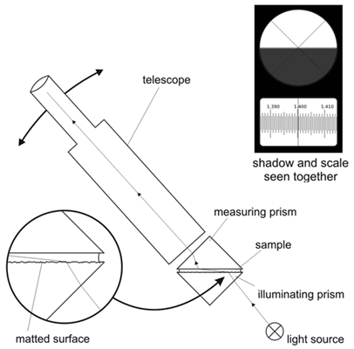

Laboratory work # 29
Determination of the laser wavelength using a diffraction grating.

Work Objective: The study of diffraction of monochromatic light using a diffraction grating.
Accessories: Laser, diffraction grating, screen, measuring ruler.

Theory.

Light rays in an optically homogeneous medium propagate rectilinearly. If light encounters an obstacle in its path, then, deviating from the straight path, it penetrates into the region of geometric shadow. This phenomenon is called diffraction of light. Diffraction is very strong when the wavelength of light λ is comparable to the dimensions of the obstacle l, i.e. λ ⁓ l.
Of great practical importance is the diffraction observed when light passes through a two-dimensional diffraction grating. A diffraction grating is the set of a large number of identical slits spaced apart from each other at the same distance (Fig. 1).
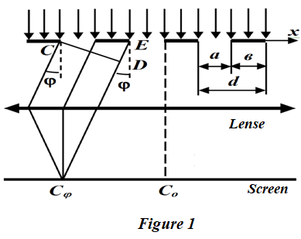
A transmission grating can be made by cutting parallel grooves on a glass plate with a precision ruling machine. The spaces between the grooves are transparent to the light and hence act as separate slits. Diffraction gratings used in various areas of the spectrum differ in size, shape, material of the surface, the profile of the grooves and their frequency (from 100 to 1200 grooves /mm).
If the width of each slit is equal a, and the width of the opaque sections between the slits is b, then the quantity d = a + b is called slit separation (period) of the diffraction grating. Amplitudes of oscillations of radiation of the same direction from all the slits are equal.
The result of the addition of secondary waves (wavelets) depends on the phase difference of the rays from identical points of adjacent slits (for example, C and E). If the condition

ED = d∙sin φ = ± k∙λ, where k is the order of maximum k = 0, 1, 2, ... (1)

then, the constructive superposition of the waves (the maximum of interference) occurs and a diffraction maximum is observed at the point C in the focal plane of the lens.
Let us consider a method for determining the wavelength of laser radiation using a diffraction grating. The installation scheme is shown in Fig. 2

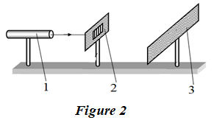
Monochromatic visible radiation from the optical quantum generator 1 (laser) falls on the diffraction grating 2, located perpendicular to the direction of light propagation. The diffraction pattern is observed on screen 3, located behind the diffraction grating.
Moving the screen, you can change the distance between the main maximums. Using the condition of the maximum of the diffraction grating, it is possible to determine the wavelength of monochromatic laser radiation.
From equation (1)
$λ\text{=}\frac{d∙ sin φ}{k}$ (2)

At small diffraction angles sin φ ≈ tg φ. From Fig.3 we can see that tg φ = x/L, where L is the distance from the diffraction grating to the screen, x is the distance from the central maximum to the k-order maximum. Taking this into account in (2), we have:

$λ\text{=}\frac{d∙ x}{k∙L}$ (3)

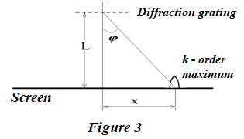

Work Progress.

1. Turn on the laser
2. Set the screen at such a distance from the diffraction grating that it will produce a clear image of several maxima.
3. Determine the distances x₁, x₂ and so on between the central maximum and the maxima of the 1st, 2nd, 3nd orders.
4. Measure the distance from the screen to the diffraction grating L.
5. Calculate the wavelength according to known values x, L, d and k according to formula (3).
6. Repeat the test several times for each visible order of diffraction maximum.
7. Calculate the absolute and relative errors of the experiment.

Data table

№ | k | $$d,m$$ | $$X,m$$ | $$L,m$$ | $$λ,m$$
1
2
3
4

Questions to the laboratory work.
Diffraction of light. Fresnel diffraction. Diffraction from one, two and several slits. Diffraction grating.

Laboratory Work # 31
Studying of the Malus's law and determination of the degree of polarization
of the laser radiation.

Work Objective: The study of the law of Malus and the determination of the degree of polarization of laser radiation.
Accessories: Laser, polarizer, micro-ammeter and photocell.
Short theoretical information
According to the wave theory, visible light is an electromagnetic wave. The electromagnetic wave is transverse: the vectors of the electric $\overset{→}{E}$and magnetic $\overset{→}{H}$field strengths of the wave are mutually perpendicular and lie in a plane perpendicular to the wave propagation velocity vector, and the vectors $\overset{→}{E}$,$\overset{→}{H}$, and form the right-screw system.
In the natural light, the oscillations of the vectors $\overset{→}{E}$and $\overset{→}{H}$occur with equal probability in all possible directions and these oscillations randomly replace one another. (Fig. 1a). Polarized is the light in which the directions of the light vector are somehow ordered.
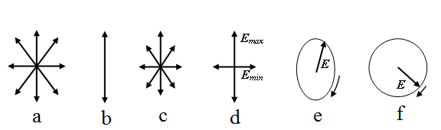
Figure 1

The light can be plane (or linearly) polarized, elliptically polarized, circularly polarized and partially polarized. Light is called plane (or linearly) polarized if the oscillations of the light vector occur only in one plane (Fig. 1b). For historical reasons, the plane of polarization was not the plane in which the vector$\overset{→}{E}$ oscillates but a plane perpendicular to it.
Linearly polarized light can be obtained from natural light by devices called polarizer (see Figure 2). These devices freely pass vibrations parallel to the plane of the polarizer.
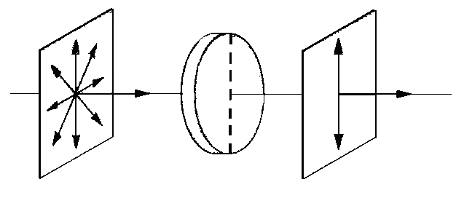
natural light polarizer Linearly polarized light
Figure 2

To study polarized light, another polarizer is used (it will be called an analyzer). We put two polarizers in the path of the natural ray, the planes of which form an angle ϕ. Let the plane-polarized light of amplitude E_{o} and intensity J_{o} ⁓ E_{o}² fall on the analyzer, that is, the second polarizer. Through the structure will pass the oscillation component with amplitude E = E_{o}∙cosϕ. Consequently, the intensity of the transmitted light is given by:
$$J=J_{0}{\text{cos}}^{2}ϕ$$
This relationship is called the law of Malus.
The light in which the oscillations of one direction prevail over the oscillations of other directions is called partially polarized (Fig.1c).
If we pass partially polarized light through the polarizer, then as the device rotates around the beam direction, the intensity of the transmitted light will vary from J_{max} to J_{min} (Fig. 1d), and the transition from one of these values to the other will occur when rotates to the angle ϕ = π/2.
The degree of polarization is the expression:
$P=\frac{J_{\text{max}}−J_{\text{min}}}{J_{\text{max}}+J_{\text{min}}}$ (1)
For plane-polarized light J_{min} = 0 and P = 1; For natural light J_{max} = J_{min} and P = 0.
Light is called elliptically polarized if the light vector (vector$\overset{→}{E}$) changes with time so that its end draws an ellipse (Fig. 1e). Elliptically polarized light can be obtained by superimposing two coherent plane polarized lightwaves with a certain phase difference of oscillations whose oscillation planes are mutually perpendicular. When the phase difference is equal to an odd number of π/2, and the equal amplitudes of the waves, the ellipse becomes a circle (Fig. 1f).

Installation Description

The scheme of the experimental setup is shown in Figure 3. A polarized light beam from the laser 1 is incident on the polarizer mounted on the rim 2. The polarizer can rotate together with the angle indicator 3 relative to the fixed disk 4. The disk has a scale, allowing to determine the angle of rotation. Passing through the polarizer, the light hits the surface of the photodiode 5. Under the action of light, a photo-emf is produced in the photodiode. The voltage on the photodiode is proportional to the light intensity. Considering that the photocurrent is proportional to the intensity of the incident light, we can write: i ⁓ J.
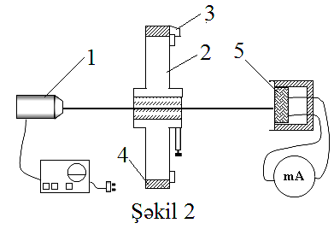

Figure 3

The work progress

- With the laser turned off, determine the zero point of the microammeter when the photocell is open (background photocurrent).
- Turn on the laser, determine the current i_{o} corresponding to the maximum intensity of light passing through the polarizer.
- Rotate the polarizer to the different angles ϕ and note the corresponding values of the current in the table.
- Plot the graph of $i=f({\text{cos}}^{2}ϕ)$ dependency according to the table.
- Determine the degree of polarization according to formula (1).
- Repeat experiment 6 times.

Data Table

_{ϕ, degree} | $$i$$ | $$\text{cos}ϕ$$ | $${\text{cos}}^{2}ϕ$$
0
10
20
30
....
90
100

№ | $$i_{\text{max}}$$ | $$i_{\text{min}}$$ | $$λ=\frac{d(l/2)}{\text{LK}}=\frac{d⋅X}{L⋅K}$$ | $$ϕ_{\text{max}}$$ | $$ϕ_{\text{min}}$$ | $$Δϕ$$
1
2
3

Questions for laboratory work. Polarization of light. The laws of Malus and Brewster.

Laboratory Work # 32
Determination of the Stefan-Boltzmann constant.
Work Objective: Studying of Stefan - Boltzmann's law and get acquainted with one of the methods of determining of Stefan - Boltzmann constant by optical pyrometer.
Accessories: Installation for determining the Stefan - Boltzmann constant, power meter, optical pyrometer.
Short theoretical information
All bodies at any temperature radiate electromagnetic waves. These waves are caused by chaotic thermal motion of atoms and molecules that make up the body, and such radiation is called thermal radiation. The energy of the radiation corresponding to different regions of the spectrum, is not the same and depends on body temperature. For example, at a temperature of 900 - 1000 K, the maximum radiated energy is in the infrared region of the spectrum. With increasing temperature the fraction of radiation energy in the visible part of the spectrum increases.
Quantitative characteristic of thermal radiation is the spectral density of body emittance (radiant emittance)- the radiated energy from unit surface area per unit frequency range:
(1)
where dW_{f,T} - the energy of the electromagnetic radiation emitted per unit time from an area dA of the body surface at temperature T in the frequency range of f to (f + df).

The ability of body to absorb the radiation incident upon them is characterized by spectral absorptivity:
(2),
showing absorbed part of the electromagnetic wave energy incident per unit body surface area at frequency region of f up to (f + df) by the body. Here dW - incident energy of f up to (f + df) region and dW_{absor} - absorbed energy at the same region of frequencies.
The body with ability to absorb entirely all incident radiation at all temperatures and any frequency, called a perfect blackbody. Consequently, the absorptivity of a perfect blackbody for all frequencies and temperatures are identically equal to unit.
Based on the thermodynamics and analyzing equilibrium radiation conditions in an isolated system of bodies Kirchhoff found that the ratio of the emittance and absorptivity do not depend on the nature of the body, it is the same universal function of frequency and temperature for all bodies and is equal to the emittance of the perfect blackbody E_{f,T},
(3)
The energy flow emitted by the unit surface of the blackbody in all directions (within a solid angle 2π), called irradiance (integral emissivity) of the body R_{T}.
(4)
Based on thermodynamic considerations, Stefan and Boltzmann in 1884 concluded that blackbody irradiance is proportional to the fourth power of the temperature, i.e.,
$R_{T}={σT}^{4}$ (5)
where σ = 5,67∙10⁻⁸ Wt/(m²∙K⁴) is Stefan-Boltzmann constant.
For all not perfect black bodies irradiance is proportional to the fourth power of the absolute temperature too:
(6)
where ε - emissivity, which is a value between 0 and 1 (ε= 1 for perfect blackbody). ε is a ratio of the radiant emittance of the body at a certain temperature to the radiant emittance of a black body at the same temperature.
Installation Description
According to the Stefan-Boltzmann law, the body of temperature T, surrounded by the environment at a temperature T_{o} radiates energy from the unit surface area per second:
(7)
If it is known numerical value of ε, it is necessary to determine the magnitude of R', T and T_{o}.
For example, if the emitting of glow body has the form a spiral, the radiant energy can be determined from the calculation power required for heating spiral. We assume that the entire amount of heat released in the spiral goes on the radiation, then:
(8)
where - J current, - V voltage drop on the spiral A - the area of the radiating surface and P - the current capacity. From the expressions (7) and (8) σ can be obtained:
(9)
The experimental setup is shown in Fig.1. Here 1 - photoelectric pyrometer, 2 - filament lamp 3 - power meter, and 4 - the power supply.
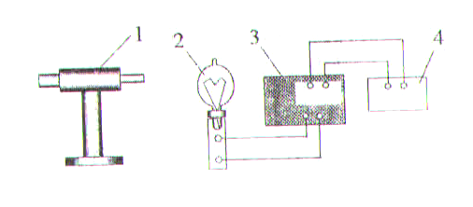
Figure 1

Photoelectric pyrometer is a device for determining the temperature of the glow-spiral. Diagram of the photoelectric pyrometer is shown in Figure 2. Where 1 - the protective glass, 2 - a housing, 3 - the diaphragm, 4 - photodiode, 5 - amplifier and 6 - measuring device | 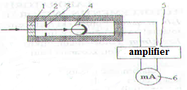  Figure 2
Work progress
- Connect the device to a voltage of 220V, for heating spiral. Rotate the auto-transformer in one direction or another to observe changes in the glowing of spiral.
- Determine temperature of the spiral at various currents not less than 5 times. At the same time noting the room temperature.
- Calculate the value of the Stefan - Boltzmann constant on the basis of formula (9).
- Calculate the average value of the Stefan - Boltzmann constant, and measurement uncertainty.

Data Table
№ | Power  P, Wt | Temperature |  |  |  |  | $$σ$$ | <$σ$>
№ | Power  P, Wt | Room |  |  | Spiral |  | Wt/(m²∙K⁴)
№ | Power  P, Wt | $$t_{0},^{0}C$$ |  | 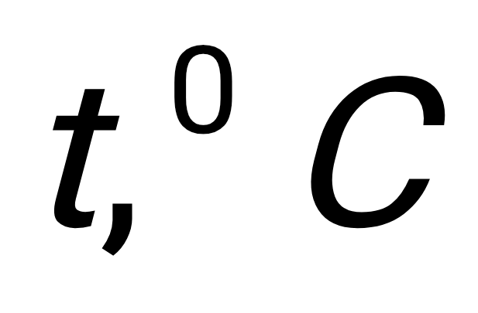 |  | $$T,K$$
1
2
3

Questions for laboratory work. Thermal radiation. Radiation of perfect blackbody. Kirchhoff's law, Stefan - Boltzmann and Wien laws. Pyrometry.

Laboratory work № 33
Definition of the integrated sensitivity of a photocell.
Work Objective: Study of the photoelectric phenomenon, determination of the integrated sensitivity of a photocell.
Accessories: Photocell, micro-ammeter, optical bench, light source (standard filament lamp), power source.
A brief theory of work.
Part of the light incident on the surface of the substance is absorbed by the atoms of substance. As a result, certain optical physical phenomena occur. One of these phenomena is the photoelectric effect. The phenomenon of the emission of electrons under the action of electromagnetic radiation is called the external photoelectric effect (photoelectric effect). In studying the photoelectric effect, the following regularities were established:
1. The maximum initial speed of photoelectrons is determined by the frequency of light and does not depend on its intensity.
2. For all substances there is a red border of the photoelectric effect, i.e., the smallest frequency f_{o} at which an external photoelectric effect is still possible.
3. The number of photoelectrons ejected from the substance per unit time (photocurrent of saturation) is directly proportional to the intensity of light.
These regularities were explained by A. Einstein on the basis of his proposed quantum theory of the photoelectric effect. According to this theory, each quantum of light is absorbed by only one electron. Therefore, the number of ejected photoelectrons should be proportional to the intensity of light. The energy of the incident photon is expended on the electron to perform the work of the output A from the substance and on the message to the kinetic energy emitted by the photoelectron
(1)
Equation (1) is called the Einstein equation for the external photoelectric effect.
It is possible that the quantum energy absorbed by electrons is insufficient for their emitting from matter. In this case electrons leave atom, stay inside matter and the number of free electrons increase, which leads to a decreasing of the electrical resistance of the substance. This phenomenon is called the internal photoelectric effect, which is observed in some dielectrics and semiconductors. Devices working on the basis of an internal photoelectric effect are called photocells.
In this work is used a selenium photocell with a barrier layer. The selenium photocell consists of a metal plate with a thin (0.1 mm) selenium film applied on its surface (Fig. 1).  Selenium film is covered with a very thin (10⁻⁶ m) layer of gold (this layer in the figure is enlarged).  At the place of contact of the metal with the semiconductor, a barrier layer (Q) is formed, Which allows electrons to pass only in one direction. When the sensitive surface of a photocell is illuminated, free electrons form as a result of the internal photoelectric effect. | 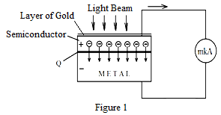
As a result of chaotic motion, electrons diffuse through the barrier layer and an excess of electrons is formed in the metal near this layer. The semiconductor, which has lost electrons, is charged with a positive charge. Thus, a potential difference is created between the semiconductor and the metal and the resulting current is detected by a micro-ammeter.
Photocells with a barrier layer are working as a current generator, converts light energy into electrical energy. In barrier layer elements, semiconductors such as selenium, copper oxide, potassium, germanium and antimony are used. The current produced by the action of light is called a photocurrent, and its magnitude i is directly proportional to the luminous flux Φ falling on the photosensitive surface of the photocell:
$i=γФ$ (2)
Where γ, is one of the main characteristics, and called the photosensitivity of a photocell. The integral sensitivity of a photocell is equal to the photocurrent created by a unit luminous flux.
$γ=\frac{i}{Ф}$, (3)
The spectral sensitivity of a photocell is a quantity that is equal to the photocurrent created by a unit of monochromatic luminous flux.
If E is the illuminance of the surface of the photocell, and A is the surface area, then the luminous flux will be
_{Ф = E∙A} ( 4)
A point source with a luminous intensity J at a distance R creates an illuminance
$E=\frac{J}{R^{2}}\text{cos}α$ (5)
Then the luminous flux incident on the circular surface of the photocell with a diameter d is determined by the expression:
$Ф=\frac{{πd}^{2}}{4}⋅\frac{J}{R^{2}}\text{cos}α$ (6)
where α - the angle between the light ray and the normal to the surface. Taking into account (6) in (3), for the sensitivity of the photocell, expression
$γ=\frac{4R^{2}i}{{πd}^{2}J\text{cos}α}$ (7)
If the light beam falls perpendicular to the surface, then cos α = 1 and
$γ=\frac{4R^{2}i}{{πd}^{2}J}$ (8)

Installation Description

The experimental setup is shown in Fig.2. Here S is the light source.

Photocell
88

mkA
S
Scale
Fig. 2

Work Process

- After installing the photocell, note the distance to the light source.
- After connecting the micro-ammeter to the photocell, illuminate the photocell with a reference lamp and note the photocurrent strength that has arisen.
- Having measured the diameter of the photosensitive surface of the photocell, calculate by its formula 8 its sensitivity.
- Repeat the experiment for different distances between the photocell and the light source.
- On the basis of the data obtained, calculate the relative error of the experiment.

Data Table.

№ | _{R, m} | _{i, mkA} | _{d, m} | _{J, cd} | γ, A/lm
1
2
3
4

Questions to the laboratory work. The phenomenon of the photoelectric effect, the internal and external photoeffect.Retarding voltage. Laws of photoelectric effect. Photometry.

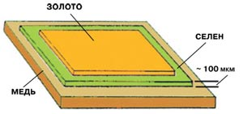

Laboratory work № 34
Determination of Planck's constant by using LED.
Work Objective: Studying one of the methods for the determination of the Planck constant.
Accessories: LED, rectifier, voltmeter, an optical table, diffraction grating, ruler.

A brief theory of work.

In 1900, German physicist Max Planck made the assumption that the electromagnetic radiation has not only the wave but also a quantum (corpuscular) properties. Having studied the spectral density of the irradiance absolutely black body, Planck proposed the quantum hypothesis, according to which the heated body doesn’t radiate energy continuously, but with a certain portions - quants, where the energy of quant is determined is E=hf ,where f - frequency of the radiation, and h- Planck's constant. Planck's constant is a fundamental physical constant. Unit for Planck's constant is [h] = J×s
Determination of Planck's constant in this work based on the study of the characteristics of Light emitting diode (LED) - the device that converts electrical energy into light. Below is detailed information on the semiconductor diode and LED.
Electro-conductivity of semiconductors is intermediate between dielectrics and conductors. In the n-type semiconductors majority carriers are electrons and in the p-type semiconductors - positive "quasi-particles" called "holes".
In contact of these two different types of semiconductors (1a) electrons of the n- type semiconductor diffused into the p - type semiconductor and the holes from the p - type semiconductor into the n- type semiconductor. As a result, unbalanced positive charge is collected in the border layer of n-type semiconductor and negative charge is collected in the border layer of p-type semiconductor. These contact areas are known as p-n or n-p junctions. Inter-diffusion continues as long as the contact potential difference reaches a certain value U_{con} (or a certain value of the electrostatic field E). If a direct voltage is applied to the external contacts of semiconductors (1b) the electric field arises which opposed to the contact potential difference. | 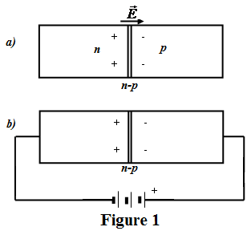
This field reduces the width and the electrical resistance of the barrier layer. As a result, the number of particles, passing through the n-p junction increases sharply and an electric current arises.
If you apply a reverse voltage, i.e., connect the n- type semiconductor to a positive and p- type to the negative terminal of the current source, in this case through n- p junction the electric current does not flow. Thus, the device with n- p junction acts as a rectifier, i.e., current flows in one direction only through the system (diode).
On the other hand, on the basis of the n- p junctions can be created devices (by selection of appropriate materials), which emit light due to the transition of electrons in the p - region and recombination with holes when they connected to power supply directly and U>U_{con}. Emission may be accompanied also by transition of the holes in the - area. This system continuously emits light and is called a LED (LED). (Fig.2) LED is a device for converting electric energy directly into light. | 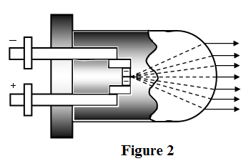
Usually LEDs made of type A^{III} B^{V} compounds with eV band of gap zone 1,5-2 eV (for example GaP - gallium phosphide), which emit red or green light. Volume of LED is only 200 mm³. With low-cost, long service life and negligible power consumption LEDs are widely used in electronics and daily life.
LED Operation. With an increase in the direct voltage applied to the LED, the current increases very slowly. After achieving a certain voltage value it begins a sharp rise in current, whereby the LED starts to emit light. The dependence of the current strength of the voltage is shown in Figure 3. At each act of recombination of an electron with a hole emitted photon with energy E = hf. With the passage of electrons through the n-p junction the external electric field does work A = eU_{o}, where f- where emission frequency, e - electric charge of the electron, U_{o} - the magnitude of voltage needed to p-n junction of LED to emit a light. In this way: | 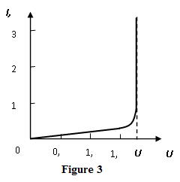
$hf\text{=}eU_{o}$ or $h\text{=}\frac{eU_{o}}{f}$
and $h\text{=}\frac{eU_{o}}{c}$ (1)
Here we replaced the frequency in accordance to the formula: f=c/λ.
This expression is the working formula for the determination of the Planck constant. Thus, to find the h empirically, it is necessary to know the numerical values U_{o} and λ. The value of U_{o} is determined from the readings of the voltmeter connected to LED.
To determine the length of the monochromatic radiation is used a diffraction grating. Instead of the lens and the screen, traditionally used to determine the wavelength by means of a diffraction grating, will use the eye: the lens plays a role of an optical system of the eye and the screen - its retina (Figure 4). If direct look at the LED through the diffraction grating, the observer will watch a diffraction pattern. According to the condition of the diffraction peaks: d∙sinϕ= kλ (d - is the lattice constant, and k- order of maximum) wavelength can be determined.  $\text{=}\frac{d∙sin}{}$ (2)  On the other hand, as seen from Figure 4, | 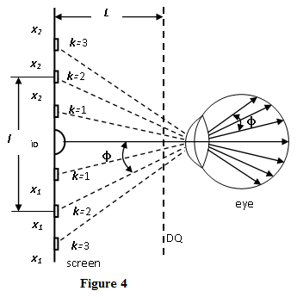
$$tg\text{=}\frac{l\text{/}2}{L}\text{=}\frac{X}{L} ∧ sin≈tg$$
so:
$\text{=}\frac{d∙(\frac{l}{2})}{Lk}\text{=}\frac{d∙X}{Lk}$ (3)

Work Process

- Assemble the electric circuit as shown in Figure 5, and pay attention to the correct connection polarity power supply to LED.  - To achieve a LED emission by varying the voltage.  - Mark voltage at which emission process begins. Repeat experiment at least 5 times.  - Slowly raising the voltage across the LED, up 0.5, to observe obtaining of consequent peaks through the diffraction grating. | 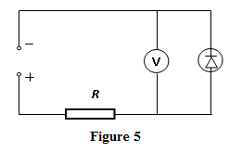
- By selecting a certain distance between the grating and LED, noting the distances X1 and X2 between the center and the various peaks on either side of it.
- Repeat measurements of paragraph 5, for different values of L.
- According to the formula (3) calculate λ and for each pair of X and L.
- On the basis of formula (1) calculate the Planck's constant
$$h\text{=}\frac{e{\underline{U}}_{o}\underline{}}{c}$$
Assess the difference between the calculated and the known Planck constant by comparing the results obtained (${\underline{U}}_{o} ∧ \underline{}$ are average values of voltage and wavelength).

Data Table 1

№ | _{Uo,i} | $${\underline{U}}_{o}$$
1
2
3
4
5

Data Table 2

$$L$$ | $$k$$ | $$x_{1}$$ | $$x_{2}$$ | $$l=x_{2}−x_{1}$$ | _{λ}
$$L_{1}$$ | 1  2  3
$$L_{2}$$ | 1  2  3

Questions to the laboratory work. Planck's hypothesis. Planck's constant. Photons. The light diode and how it works.

